“Exams in the perspective of an intensive use of software in regular courses”
Angel Balderas Puga, Universidad Autónoma de Querétaro, Instituto Tecnológico de Querétaro - Mexico
balderas@sunserver.uaq.mx
Abstract
In this paper is detailed my own experience with exams in regular mathematics classes in an intensive software-supported learning environment. No experimental groups or gifted students were included in this experience. Some important software-induced changes when computers are allowed during all exams are discussed. In the same way, some aspects of the phases pre- and post-examination are discussed but the attention is focused on some problems around the phase of taking the exam. I support the idea that computers allow us do a better examination and that students like this new kind of work.

Introduction
In 1994 I began to utilise information technology in the administration of regular examinations, and have done so continuously since that time. The majority of my experience has been with the Faculty of Engineering in a Mexican university, working with first and second year students. The courses involved are offered on a semester basis and are consistent with the broad outlines of the official national curriculum. They are presented in a traditional treatment, but being of a highly technical nature, contents, approach, focus and the progression of the syllabus are influenced greatly by information technology. Consequently, exams reflects such changes. Four courses are involved: Calculus, Vector Calculus, Linear Algebra and elementary Ordinary Differential Equations.
In my country, young people traditionally enter the university at about 18 years of age, having completed 3 years of high school. Thus, the first and second year students are usually 18 or 19 years old, with a smaller number of 20 year olds. In 1994 almost all students were entering the university with no experience in using math software, but with a minimum of experience in the use of calculators and programming. Today, however, many new students bring, at a minimum, some experience in the use of math software (especially, Dynamic Geometry Software, such as Cabri-Géomètre and Geometer's Sketchpad, and also the Mexican software Conicas) and calculus software (like Derive and the Mexican software Calcula).
During the first 2 years of matriculation, students use various math software, depending on the course involved. They use programs such as Derive, Calcula, Gyrographics, Matlab, and Phaser, while professors have access to more powerful and sophisticated software, such as Mathematica o Maple. This more potent software is not generally available to students, principally for economic reasons. Derive is used most frequently and intensively by students, primarily because it is more reliable than the alternatives.
At the university, in addition to the normal Computer Centre, we have what we call a "Didactic Classroom", devoted to technology supported teaching. All work in the "Didactic Classroom" is teacher-assisted students do not use the facilities independently, as the purpose of the room is teaching. However, students do autonomous experimentation in the Computer Centre, or, if possible, at home. Figure 1 shows some characteristics of the "Didactic Classroom". There is a regular blackboard and 18 computers, all oriented in the same direction. The room is used by groups of 18 to 50 students, with 2 to 3 students at each computer, depending on the total number of students in the class, including the case when the class size is smaller than 18.

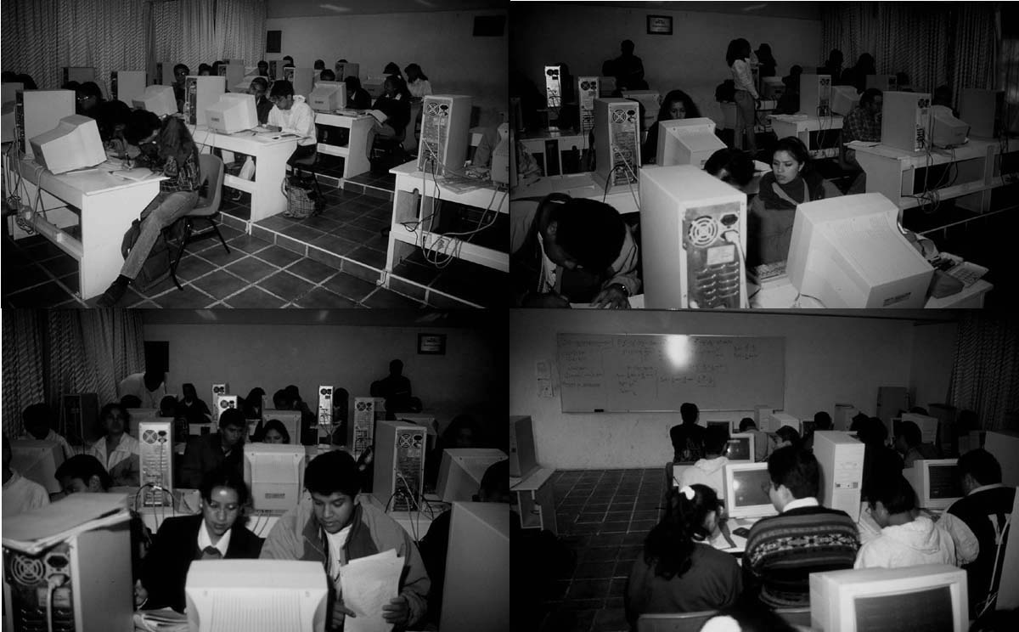
Figure 1
In respect to examinations, our experience in introducing software in math courses led to a fundamental question: Why we would teach students mathematics using information technology when they were forbidden to use it during exams? Seeing that the point was well-taken, I permitted, from the beginning, the use of calculators and software during exams. Of course, the introduction of information technology in exams was accomplished gradually, at first it was required for only a few questions. But at present, after 6 years of moving forward with information technology, many exam questions require not only a mastery of math concepts and skills, but appropriate skills using the course software as well.

Traditional vs. computer assisted exam questions, toward a "complete" examination
With respect to a better evaluation of a topic, I think the use of software has at least 4 fundamental advantages over traditional exams. These advantages imply a more “complete” evaluation of the topic since it allows you:
- To examine the students' knowledge not only in a small sample of the topic, as it is done traditionally, but almost in the totality of it. In a computer-based exam you can increase considerably the number of exercises and this allows you to, for example, cover a larger number of cases (the exercises are selected previously to guarantee that this happens) and with this the student should show that he knows what to do in each particular case;
- To examine, in a deeper and more global form, the students' knowledge in specific topics (for example, asking additional questions in the classic exercises, asking theory or including more applications);
- Focus the attention to the central nucleus of a curse;
- To examine the students' mistakes in a more specific and personalized form.

Globally, these 4 characteristics (and additional ones) convert into a potential tool to perform a better evaluation for the regular courses because, in this type of courses, accreditation depends on the exams grades. Therefore, focusing on the previous characteristics, a student should be more satisfied with the grade assigned by professor since he has been evaluated in a more specified and personalized form, almost in the totality of the course, also in a deeper and global form about central aspects of a course and giving an adequate weight of the marginal aspects.
To illustrate the first three characteristics, I present two examples from a traditional course exam, both examples come from an elemental course of ordinary differential equations from an Faculty of Engineering different than mine, comparing them with exams taken by my students.
The first one (on March 1997) refers to the solution of first order equations and simply consists of 5 equations that the student must solve (see Figure 2). It can be observed from the statement that the student does not even have to classify the equations, since his professor already tells him what type are each one of them. And this is why this type of exam focus only in the evaluation of algebraic techniques and, in general, is very poor from the conceptual point of view, beside that, only two types of equations are evaluated: linear and Bernoulli type.

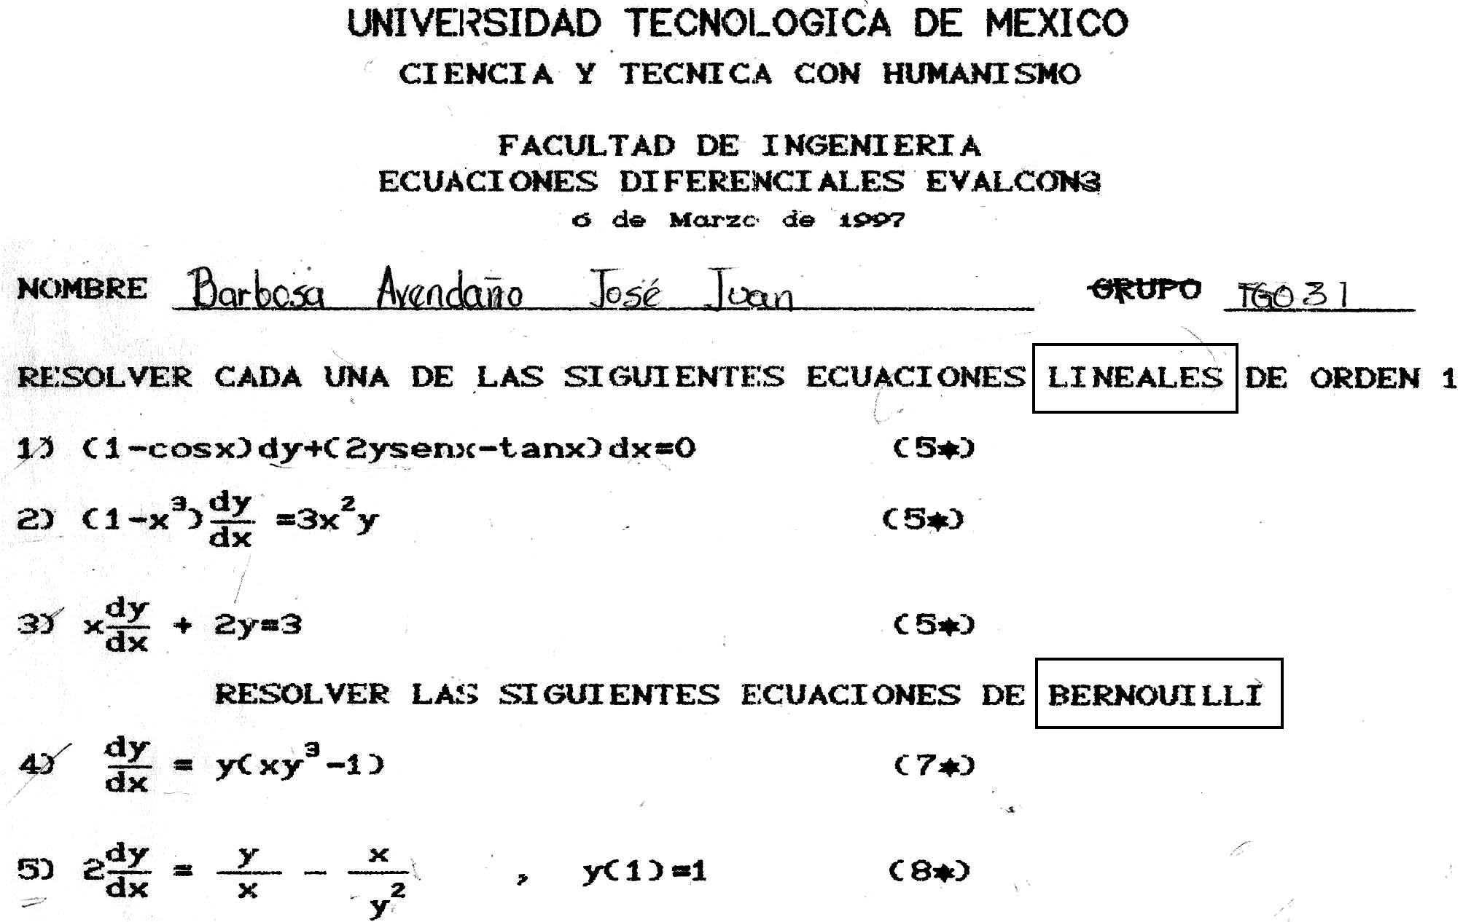
Figure 2
In comparison I present a sample of an exam applied on June 1998 in which it was allowed the use of software (see Figure 3). As it can be observed:
1. It includes explicit questions about the concepts in such a way that student not only gives a definition using his own language, but also the important characteristics of these concepts;
2. It asks for the classification of the equation obtained from previously analyzed models and for a manual solution;
3. It asks for the solution of 5 equations of different type (the solution methods for homogeneous, separable and exact equations are also evaluated, that is all type of equations discussed in class are evaluated);
4. It does not specify the type of each equation;
5. It does NOT indicate the value of the solution of each equation because this could be a tip for the student about the type of the equation;
6. It asks for explicit solutions (as much as possible) and not only for implicit solutions;
7. In a case, it asks for the graph of the general solution (that is, for a functions family) as for the description of its behavior;
8. It asks for the solution of a higher order homogeneous equation;
9. It proposes two application problems, both refer to non previously discussed in class topics and even though the precedent exam was completely devoted to this topic following an idea also expressed in (Kokol-Voljc, 1999) "the exam…becomes a learning situation…".

CHAPTER 2: SOLUTION METHODS, first order equations and constant-coefficient linear homogeneous high-order equations
NAME | Grade | Exam kind 23
 |  | June 98
1. For the next concepts, explain with your own words the following: What is their meaning? Which is their utility? Which context do they appear in? (12p c/u)
a) Integrating factor. b) n-th order differential operator.

2. According to the classification studied in chapter 2, determine the kind of equation used for modelling the pendulum’s movement. Consider the existence of friction (Course notes, Chapter 1, p. 20). Then, use the appropriate method to MANUALLY solve the easiest case, i.e. that without frictional forces.
(20p)
3. Solve the following equations or initial value problems, whichever the case. If possible, find an explicit solution. If not, simplify your solution as much as possible. (In this case, the value for each exercise will depend on the kind of equation and on additional things to do after having solved it. Minimum value is 13, and maximum 23.)
a) cosθdr - (rsenθ-e^{θ})dθ=0 b) (3x²+y)dx + (x²y-x)dy=0
c) y⁻²; y(0)=1 ; find y(0.5) d) y=x+2
e) =t²(1+x); x(0)=3 , in this case, plot the general solution and describe its behaviour.
f) y⁽⁸⁾ - 3 y⁽⁷⁾ + 17 y⁽⁶⁾ - 9 y⁽⁵⁾ + 6y⁽⁴⁾ + 108 y”’ - 148 y” - 420 y’ - 200 y =0 (25p)

4. In quantum mechanics, the analysis of the Schrödinger equation for the harmonic oscillator yields to consider the Hermite equation: y” - 2x y’ + λy = 0 where λ is a parameter.
a) Indicate what kind of equation is it, according to classification given in page 1 of the Course notes.
b) For λ=4, determine whether or not the function y₁=1-2x² is a solution for the given equation.
c) If so, use the order reduction formula to obtain an integral representation of a second linear-independent solution of Hermite equation.
(25p)
5. When a family of curves intersects another family at an specific constant angle α (α≠π/2, if α=π/2 both families are orthogonal), the first family is referred to as an ISOGONAL FAMILY of the second one, and in this case it is said that every family is an ISOGONAL TRAJECTORY of the other. If dy/dx=f(x,y) is the differential equation describing the given family, it is possible to demonstrate that the differential equation of the isogonal family is:
$$\frac{\text{dy}}{\text{dx}}=\frac{f(x,y)+\text{tan}α}{1−f(x,y)\text{tan}α}$$
Use this result to find, for the family of lines y=cx, its isogonal family at an angle of 60°. (50p)
Figure 3
With this kind of tests, and concerning exclusively the solution methods, emphasis is made precisely on methods, instead of intermediate operations. As a matter of fact, for every equation:
- Student makes a choice on the method to follow, and this is not straightforward because equations are written in such a way that identifying its type is not an immediate step. A single equation can often be solved by several methods, and it must be translated to a standard form. (In traditional tests, when kind of equation is given, this process misses.) Then;
- Student applies the chosen method. At this stage, and as automatic solution by means of Derive utilities is NOT allowed, the student is constrained to know the manual algorithm (condition not required in application problems, where emphasis is made on how the solution is set out);
- An advantage of using a computer is that the student can easily verify his/her solution (a time-consuming issue in manual processes), which implies he/she must handle the verification concept.

For this kind of tests, students use Derive software mainly (and we can say almost exclusively) to plot and calculate the complex integrals contained in the intermediate steps, sometimes because of calculations complexity, sometimes because of lacks inherited from precedent courses. For the last case, computer is being used as a mathematical compensation tool which allows less gifted students to deal with advanced topics (in this example calculation of integrals to solve differential equations), according to (Kutzler, 1999), a very important topic pointed out as well in (Rothery, 1994; Elia, Galizia & Mascarello, 1995; Mingham & Hood, 1995, Bennett, 1995, Townend, 1994). As for the rest of the processes involved either they do not require a computer, or students prefer to carry them out manually (including algebraic simplification and derivatives calculation), which denotes kind of a judgement on selecting a tool and does not reflect an excessive dependence upon software.
The second one (April ‘97) deals with solving 2nd order equations and using Laplace transform in solving equations (refer to Figure 4). It can be seen that in almost every exercise the steps for its solution are clearly evident, and all the student has to do is to execute them, which serves to a conceptually very poor test.
Regarding Laplace transform, two calculations are requested (for two continuous functions, almost directly calculable), as well as an inverse transform and two 1st order equations (whose solution can easily be obtained with some other methods).

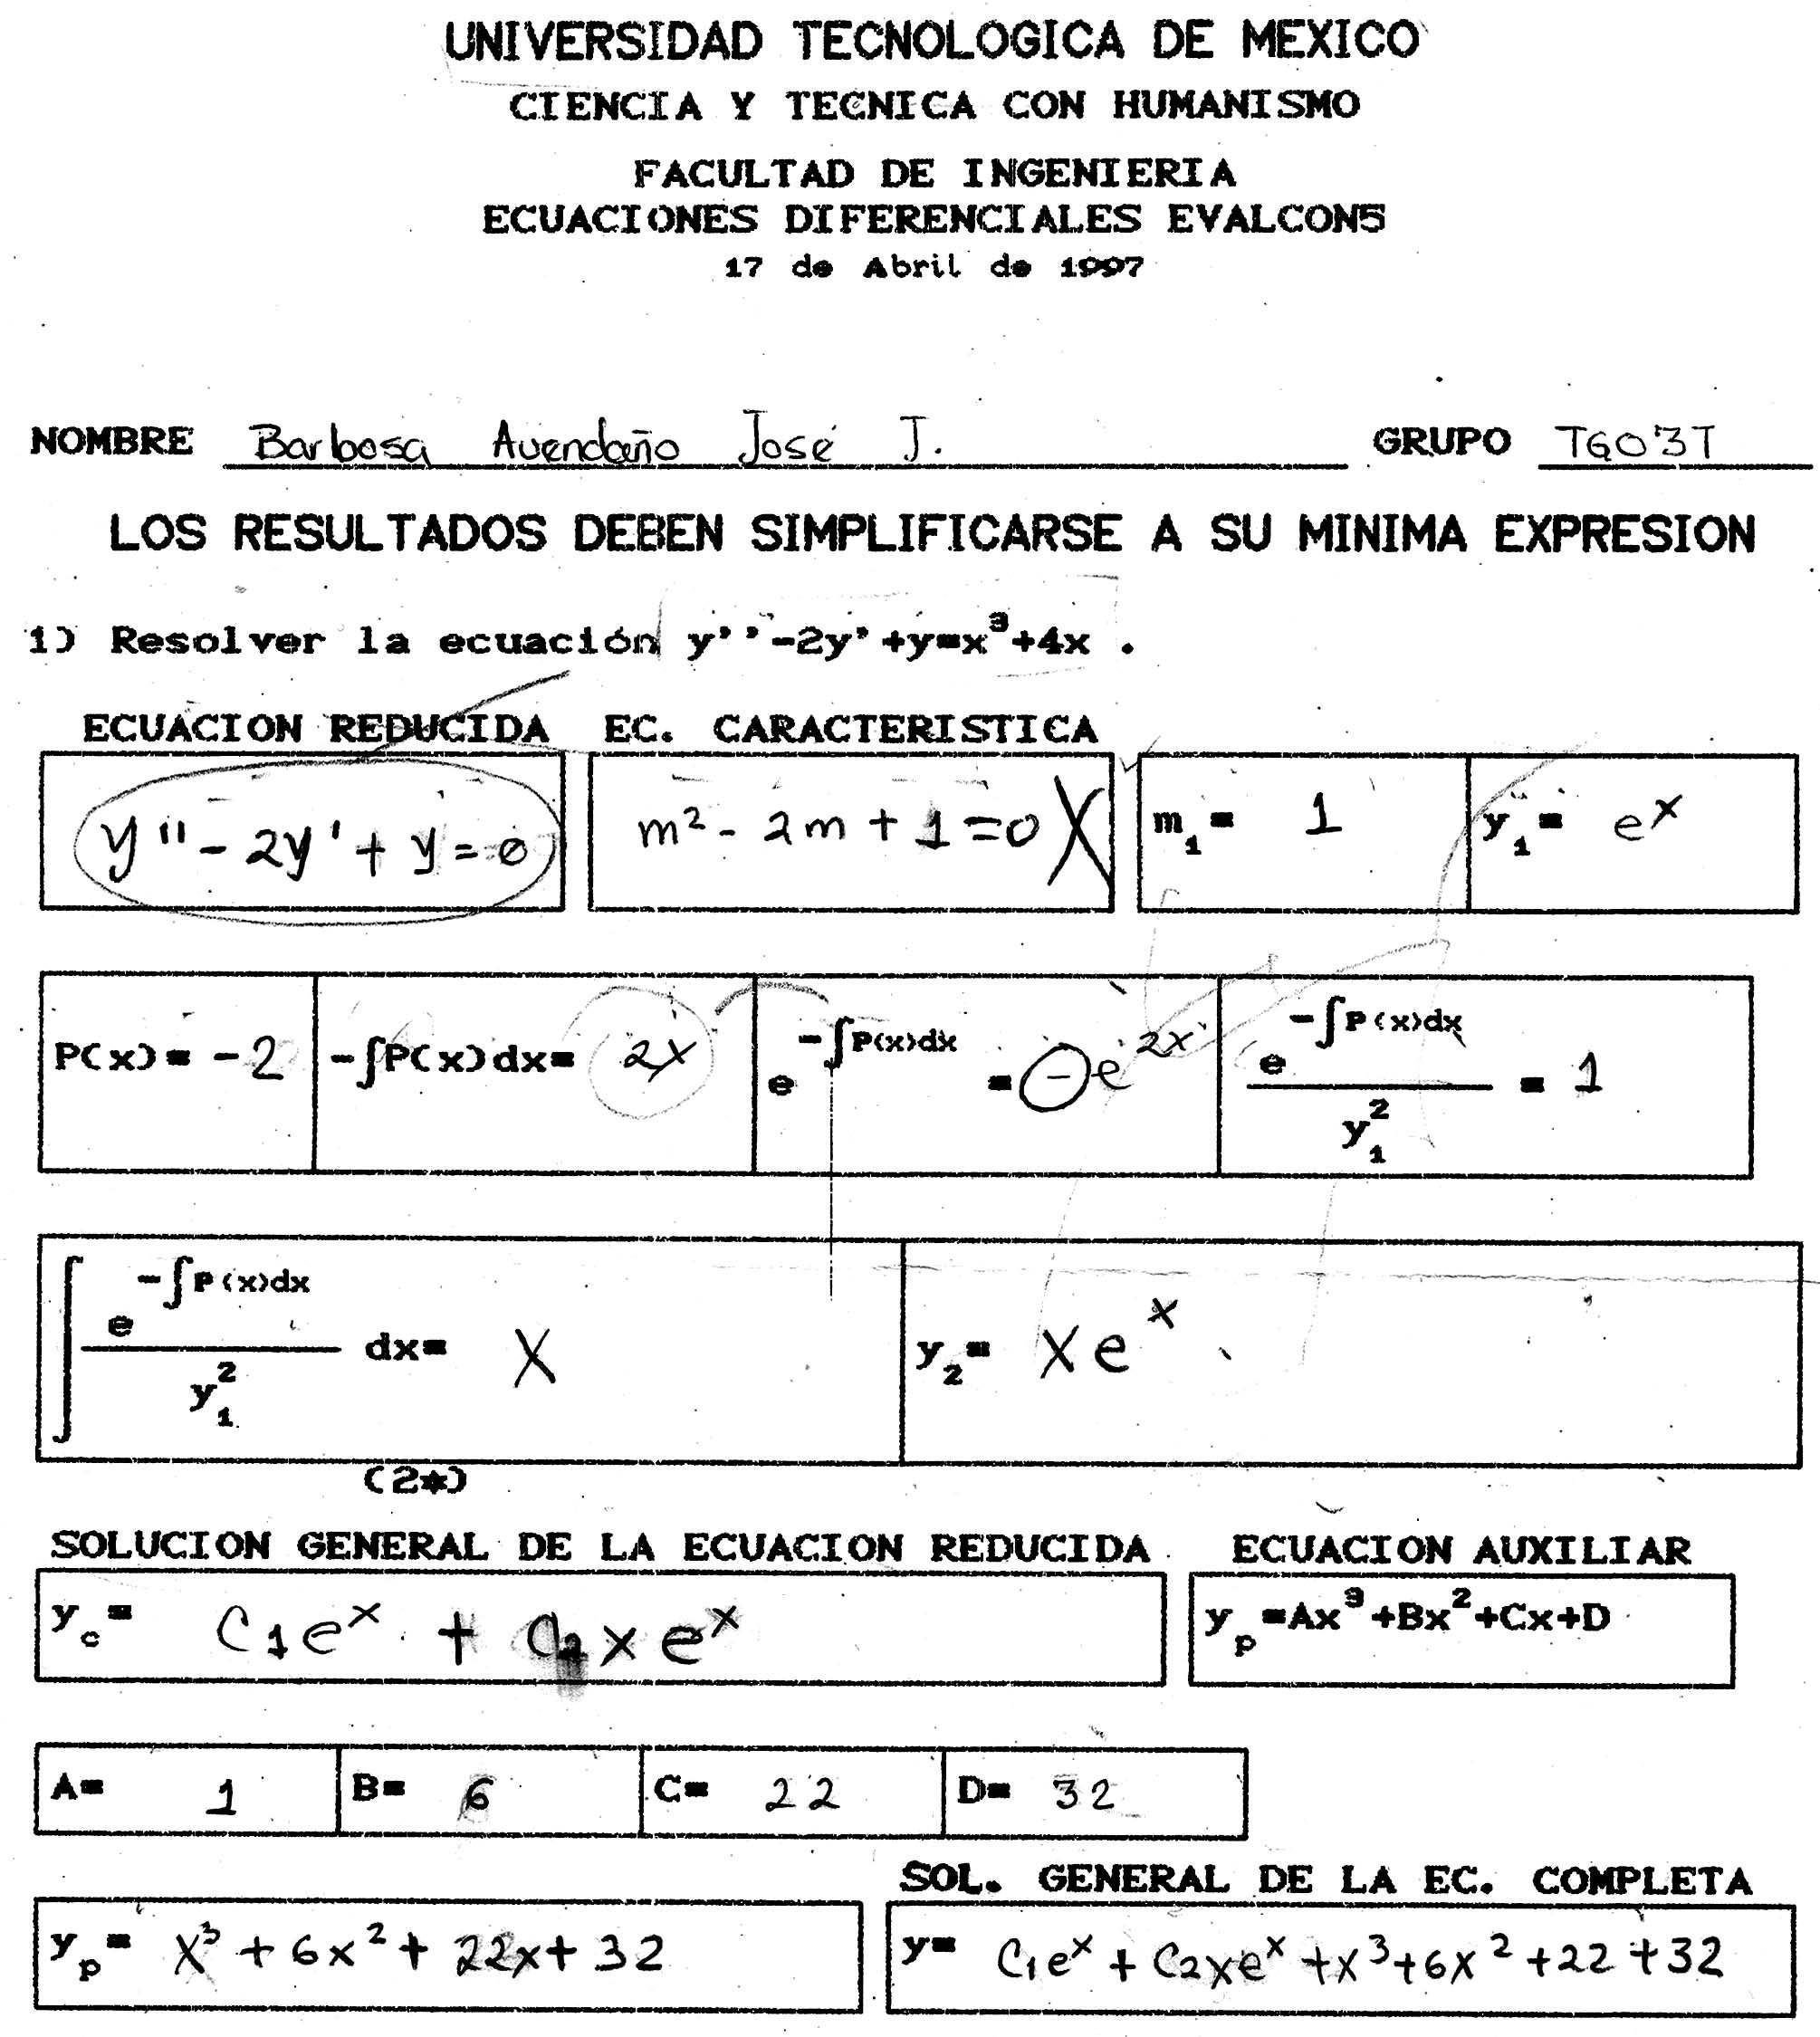 | 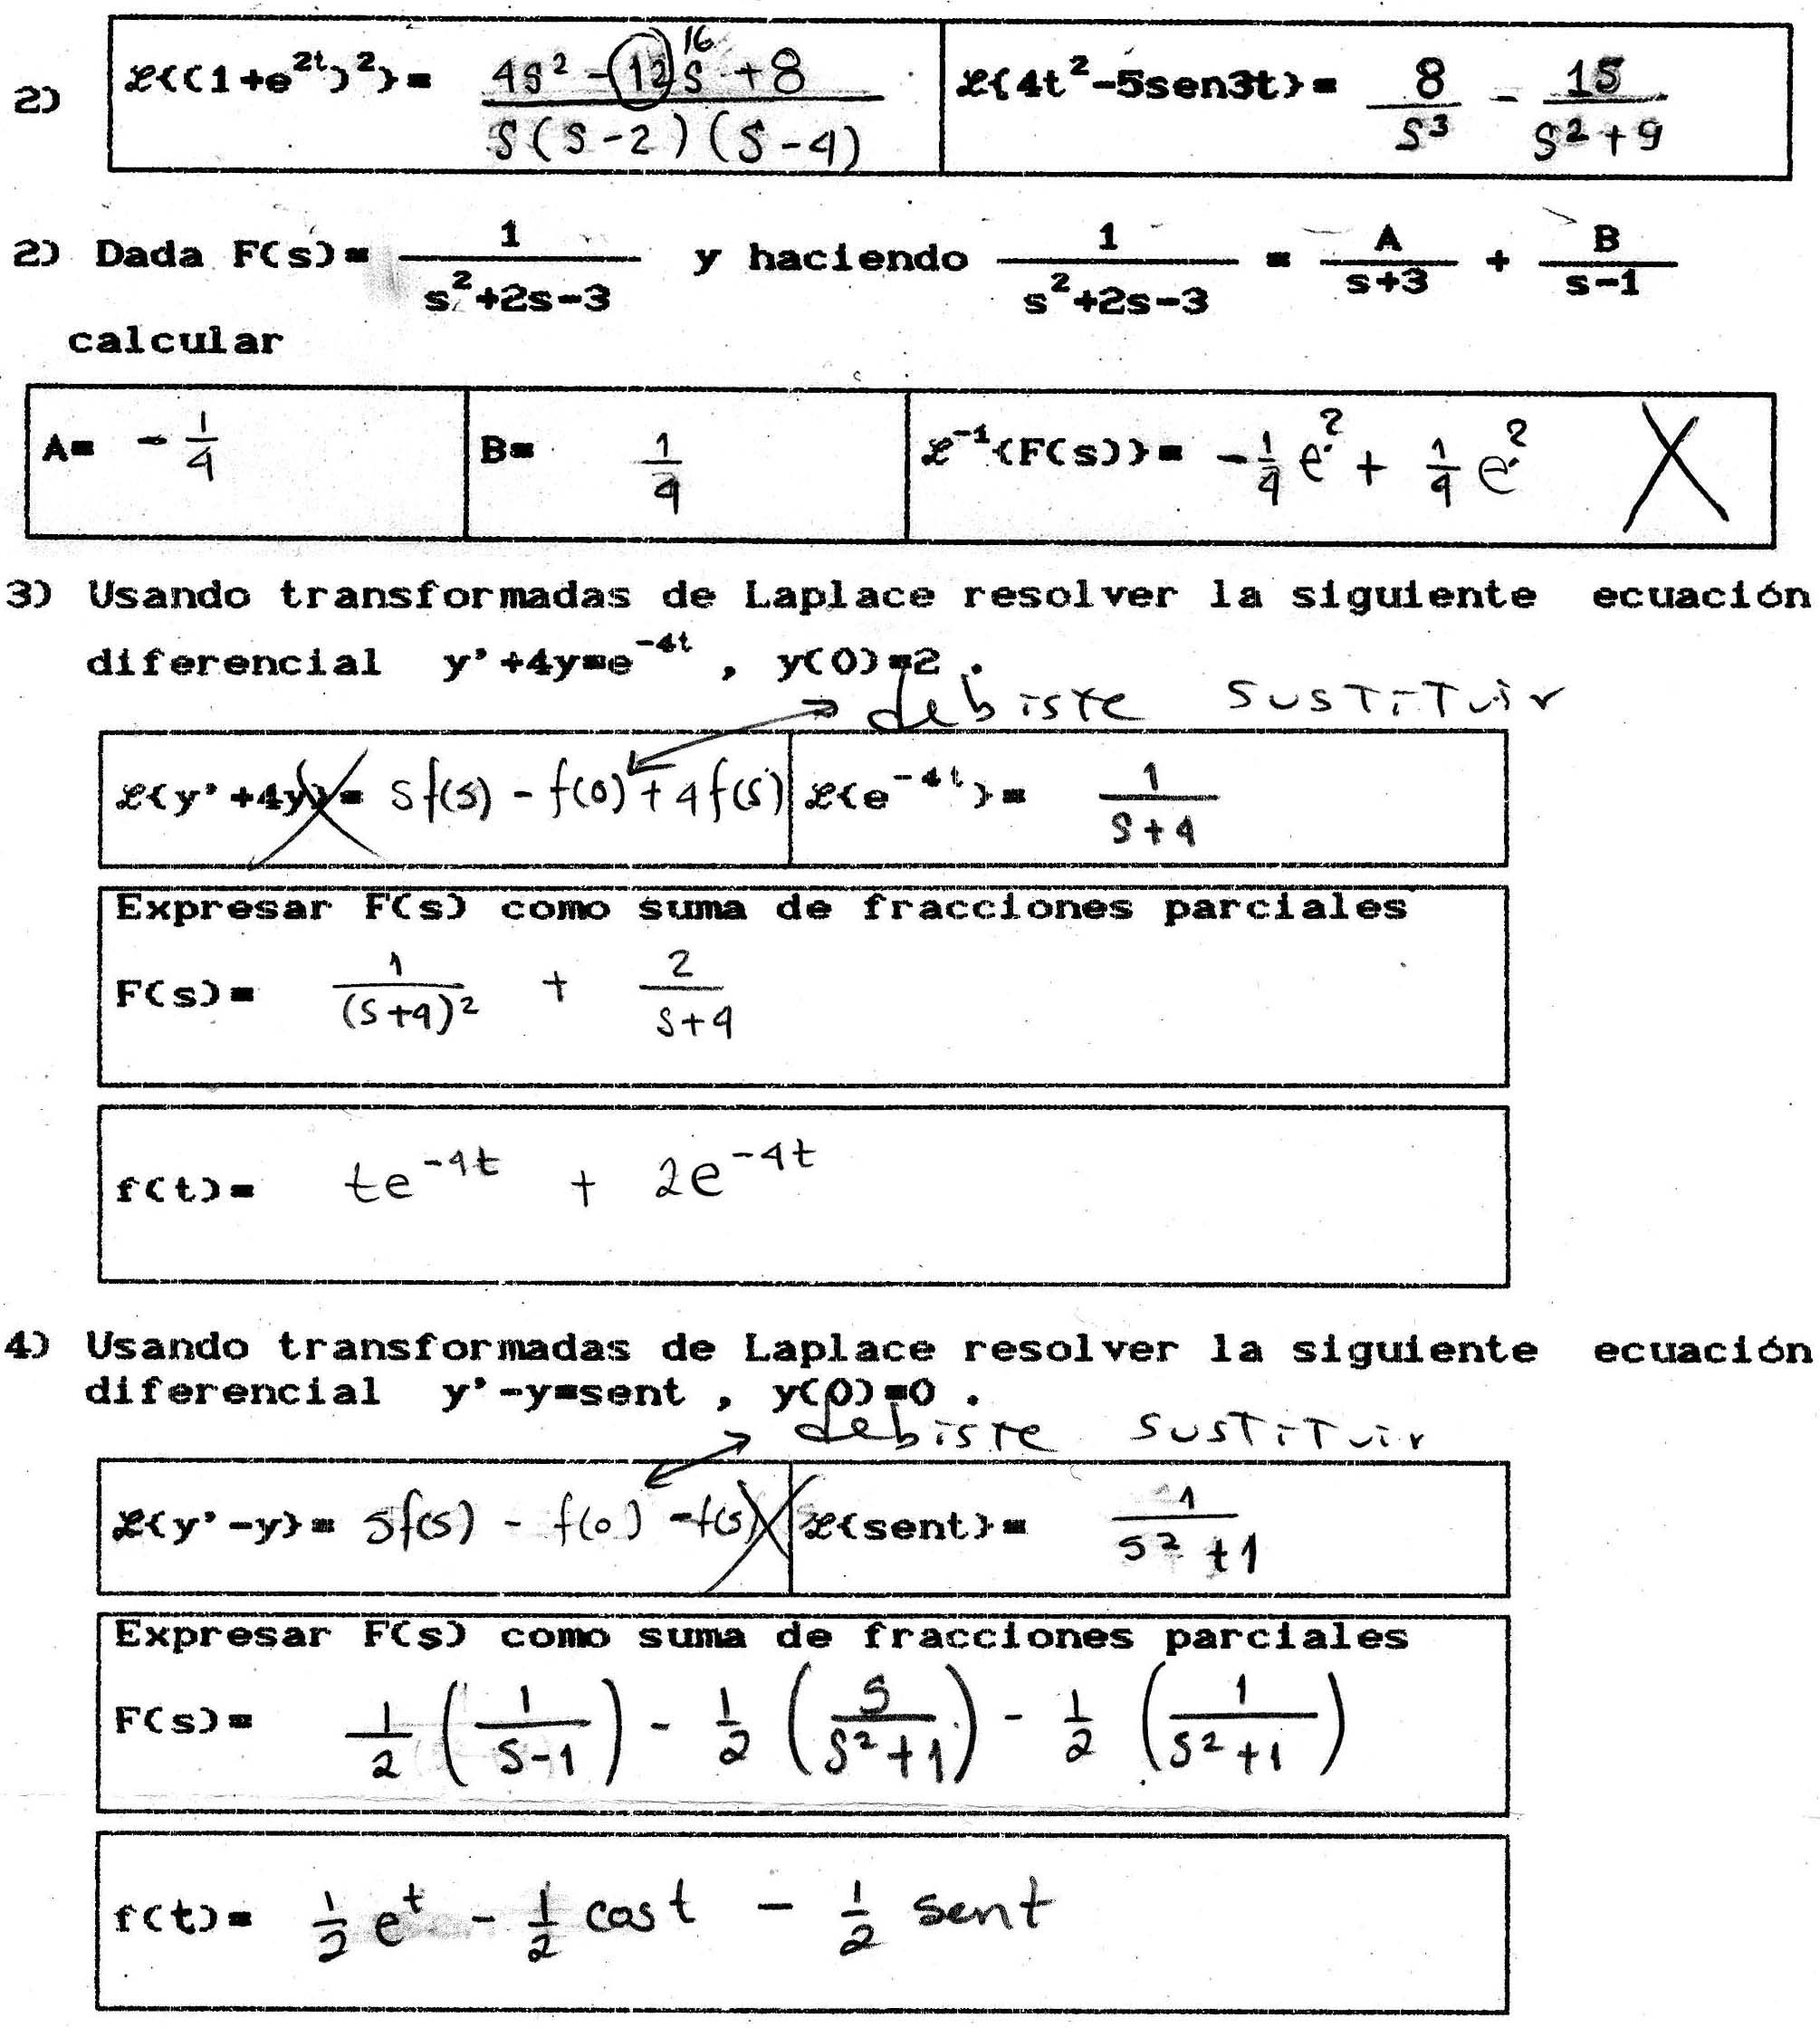
Figure 4
For comparison's sake, an exam is presented as applied in may 1998 and where software use was allowed (refer to Figure 5). As we can see:
- Explicit questions are posed concerning specific concepts for the student to give not only a definition of them in their own language, but also a description of their important characteristics (as a matter of fact, this is a constant issue throughout the course).
- The calculation of three transforms is also requested (for discontinuous functions including special ones and a periodic one).
- Solution for five equations is required, three out of them are 2nd order, one is 3rd order, another one is 1st order. One of them includes Dirac’s Delta function.
- No equation (except the second one) can be solved by any other method, or it results in a very complex process. This gives a certain mean to this particular method.

CHAPTER 4: LAPLACE TRANSFORM
NAME | Grade | Exam kind 17
 |  | May 98
1. Explain with your own words the following concepts. What is their meaning? Which is their utility? Which context do they appear in? (15p c/u)
a) Exponential growth function b) Indicial response.
2. Plot the following functions and compute their Laplace transform. (a: 10p , b: 20p ).
a) f(t) = H₁(t) - H₄(t) b) g(t) = $\left\{\begin{matrix}0 & 0≤t<2p \\ \text{sen}t & t³2p\end{matrix}\right.$
c) In problems concerning signals representation for data transmission, a g(t) signal appears coming from a half-wave rectifier, with a capacitive filter and a resistive load, as shown in the next figure. Compute the Laplace transform of this output without using Schaum Series tables.  (30 p) | 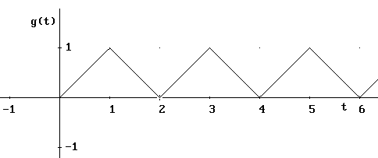
3. Solve the following initial value problems by using the Laplace transform method. JUSTIFY every one of your STEPS and simplify the solution as much as possible. (a,b,c: 60p, d:70p)
a) y” - y’ - 2y = 18e^{-t} sen3t; y(0)=0, y’(0)=3 b) y’’’ + 2y” - y’ - 2y=sen3t; y(0)=0, y’(0)=0, y”(0)=1

c) y” + 2y’ + 2y = cost δ(t-3π); y(0)=1, y’(0)=-1 d) y” + y = t ; y(π)=0 y’(π)=0

4. Solve the following integral equation. (60p)
y’(t) = 1 - sent -y(u) du, y(0)=0
Figure 5
In these type of exams, the best utility from the software is coming over calculus on inverse Laplace transform, specially with the separation into Partial fractions (show EjEcLap.doc), process which Derive can work with. Also Derive is useful on Laplace transform calculations, to obtain quickly the formula to Y(s), to verify as partial results as final results, and to analyse and study the solution, etc.
With this kind of exams, and making only reference to the solution of equations by Laplace transform method, emphasis is on the method and not on middle calculations. In this case a student must:
- Make a selection on one specific formula which depend on the order of the equation;
- Applied the method. Derive doesn’t let you to know an automatic solution, so, the student should know the manual algorithm of the solution.

The 3 characteristic above declared, are a consequence from the fact that the students do not must to take so long trying to get middle algebraic calculus, on this hand, the time that is saving is destined to work deeper on theory, make more applications (an important fact, also distinguished in Koko-Voljic, 1999) ore the same exercises but with a biggest and deeper work on (On the fist example: method selection, writing and acknowledgement from the standard forms, obtain specifically solutions, graphs of solution, etc., on the second example: an insertion of superior order equations, use of discontinuous specials or periodic functions, integral equations, reference to applications, an so on).
This process goes from traditional exams getting the solve with help of software and making gradual modifications in every examine session, analysing thoroughly the solutions that students put forward, re-examining additional bibliography, testing, building new exercises, extending the exercises exposed in the classroom, exchanging opinions with my colleagues, an so on, making at the same time by intuition and an informal way a classification from similar questions expound in (Kokol-Voljic, 1999).
Remarking on these type of exams is obvious a combination of different strategies under sight of White-Box/Black-box principle (Buchberger 1990). For example, with apprenticeship measuring of specifically differential equations algorithms we follow a White-Box strategy while we follow a Black-Box strategy for Calculus algorithms; in the apprenticeship measuring of modelling the same specific differential equations algorithms turn into a Black-Box strategy. Automatism of a process is allowed when just the focus is in other place.
Other important stuff is when is not used just one software, student decide not only when, where and how use a software (except the explicit restrictions the teacher gives), also he should select the most appropriate software to find out the solution a specific problem.
With my experience, this kind of exams also have some disadvantages (some of them in my personal opinion I don’t consider them disadvantages or else an enrichment) as much to the teachers as to the students in relation with traditional exams, in between I can point out some:
- Are disadvantageous the students which have not much information technology practice (could be with an specific software, or in information technology at all);
- Disadvantage with the students which have not much abilities to combine the work with traditional technologies ("paper-and-pencil" environment) and information technology;
- Teachers must have a suitable information technology knowledge (Not only about the software or else about equipment which is working with);
- In some cases the teacher must do a "back conversion" as much in the way to prepare as in way to revise his exams.
- Teacher, students and institutions should solve practical problems bind with exams developments, problems when are so serious become an huge unbeatable obstacle.

Students' errors and personalised evaluation
In many situations the use of software helps to better qualify a test, independently if the students use or they didn’t use a computer during this test as it can see in the following example (in this case it was necessary to use software). The following exercise was part of a test performed on March 1998 in which four kinds of tests were applied to 50 students.
"A weight with mass of 1 kg is attached to a spring with Hooke's constant of 4 and frictional coefficient of 2. Suppose that the weight is released from a height 50 cm below the equilibrium position with an initial velocity of 1 m/seg in the upward direction and there is no exists a forcing function …".
In a first question we ask the classification of the kind of movement, in a second one we ask for the solution function and then other 6 questions, in which the answer of 5 of them depends from the function obtained in the second question then if this function is incorrect, inevitably, the 5 related answers won’t coincide with correct answers. The solution function isn’t immediate and requires the use of a library from Derive with the following Syntax "dsolve2_iv(b/m,k/m,f(t)/m,t,t₀,x₀,v₀)". From statement exercise we have the following values b=2, m=1, k=4, f(t)=0, t₀=0, x₀=0.5 and v₀=-1 then the correct answer is obtained with "dsolve2_iv(2,4,0,t,0,0.5,-1)" to achieve to the solution function
x(t)= e^{−t} $(\begin{matrix} \\ \end{matrix}$$\frac{\text{cos}(\sqrt{3}t)}{2}$−$\frac{\sqrt{3}\text{sin}(\sqrt{3}t)}{6}$$(\begin{matrix} \\ \end{matrix}$
Among the students that solved this exercise not one arrived to the correct answer. To qualify in an adequate way, the professor must look for the kind of mistake committed, but he finds 7 different answers as we see in the following table.
Table 1
Student | Solution
1. Israel, Rafael, Isabel and Salvador | x(t)=e^{−t} +
2. Victor | x(t)= −
3. Susana and Julieta | x(t)= e^{−t} 50cos(t) +
4. Marco and Arturo | x(t)= e^{−t} −
5. Karina | x(t)= e^{−t} cos(t) +
6. Alfonso | x(t)= e^{−t} +
7. Jose Juan | x(t)=

Is necessary to draw the solution function and to obtain a set of values (related with the extreme values and with particular values) and other functions (the velocity and the acceleration). Naturally, from the first mistake every thing is wrong, there are some questions, Must the student not pass? Doesn't the student know to use the differential equations to solve an application problem? Doesn't the student know to use Derive to solve a differential equation? Doesn't the student know to solve a differential equation? What kind of mistakes the student had committed? What are nature and seriousness of his mistakes?
To review the results of 5 questions would implied to draw every one of the former functions to verify the supplied schemes by the students, calculate the extreme values of each function, calculate the first and the second derivative of each function, evaluate the functions in specific times, and so on, is possible to do all these actions without a computer? We point out that we consider one kind of test only and similar situations had occurred in the others tests, then we would consider about 20 different results, a really titanic work! However, if we use Derive, in a relatively fast way (among the given solutions supplied by the students and the more usual mistakes typology) it can be identified the kind of mistake because we know where do the solutions come as we see in the following table.
Table 2
Student | Syntax
1. Israel, Rafael, Isabel and Salvador | dsolve2_iv(2,4,0,t,0,0.5,1)
2. Victor | dsolve2_iv(2,4,0,t,0,0,-1)
3. Susana and Julieta | dsolve2_iv(2,4,0,t,0,50,-1)
4. Marco and Arturo | dsolve2_iv(2,4,0,t,0,-0.5,1)
5. Karina | dsolve2_iv(2,4,0,t,0,0.1,0)
6. Alfonso | dsolve2_iv(2,π,0,t,0,0.5,0)
7. Jose Juan | dsolve2_iv(4,2,0,t,0,50,2)

With this procedure the professor can identify the kind of mistake (they are showed in the following table) in each group of students and he can assign a better grade to this part of the process.
Table 3
Student | kind of mistake
1. Israel, Rafael, Isabel and Salvador | simply they took erroneously the direction of the initial velocity
2. Victor | simply he took erroneously the initial position
3. Susana and Julieta | simply they didn't the conversion from centimetres to meters
4. Marco and Arturo | they took erroneously the direction of both initial conditions
5. Karina | she took strange initial conditions, without relationship with the problem
6. Alfonso | he took a Hooke's constant and a strange initial condition, without relationship with the problem
7. Jose Juan | he wrote the coefficients in an other way, he didn't the conversion to meters and introduce a strange initial condition, without relationship with the problem

When we has identified the first mistake it’s possible a personalised evaluation, we can work with each of the solutions showed in the Table 1 because with Derive the professor has a mechanism to work the different results and to verify the others answers. We point out that, for many cases, the solution process to the other questions was irreproachable. This fact points out the software usefulness in this very important point because it has a great influence over the grade to pass or not to pass a course.

Assessment in a regular course
In (Drijvers, 1998) it's possible to find a review of the use of hand-held technology and computer algebra software for examinations in different countries in Europe which have national final examinations.
In my country the examination policy is based on the fact that high school students must do an examination for every course just like at the university level. In both levels students have to approve every single test in not more than three exams presented. If a student doesn’t pass a course after applying three times for it, automatically he must leave school or university (though he still has the possibility to begin the studies in another school or university). If a student didn’t finish the paperwork where he sets he won’t assist to that University again on time, he still must present the exam. For these reasons, in a regular course this kind of examination is critical in several ways. And like I stated in the previous lines, for information technology, less skilled students (or students with little access to this kind of technology) are in a great disadvantage.
This is why the computer based exam planning should be done very carefully. When the course begins the computer resources available for each student have to be analysed, then each student has to receive instructions about the kind of exam. Furthermore, after each exam each student receive a package that contains:
- A printout of each kind of exam applied;
- A document that details how the intermediate processes were evaluated, and that points out the exercises where more mistakes were made. All kind of mistakes, math as information technology ones (the severe mistakes made by most of the students should be discussed in class);
- If necessary, some math software files.

Besides the exam design and the problems related to checking them and give a grade, this process has other central problems such as the correct “hands-on-computer” time distribution among the students and avoid that the students copy on the test. We have tried to resolve these problems by performing the next steps.
All the exams are performed in the “Didactic Classroom”, since the students are already used to work in this workspace, some pictures are shown in Figure 6. Normally at the same time there are students from 2 to 3 different courses doing their exams (avoiding with this the possibility of having a big number of students with the same kind of exam), though sometimes some students of the same course have origin in different groups. Since we have an average of 18 computers available for a group of 100 students, the students don’t have a computer available for them for the total time of the exam. The exams normally last 3 hours and students take them in adjacent classrooms from the "Didactic Classroom".
As for the case of students from the same course, up to 4 different kind of exams per session (depending of the number of students and always with the idea of reducing the possibility of copying), the professor sits at the entrance of the "Didactic Classroom" to guarantee a minimum of equity in the time distribution for the computer, a waiting list (show espera.doc) and the time used by each student is metered (this kind of information can give valuable information, like, differences between exams on different subjects, the kind of work developed by each student, form of using the technology, and so on). The students can enter and leave several times the room, the important is the actual hands-on-computer time used.
In this way the students have to resolve their exam in “parallel” and not sequentially what means a greater effort and a greater conceptual knowledge of the tested subjects, and, like it can be noticed in the figure they not only use the computer but also calculators besides the classic paper-and-pencil environment (including the possibility of consulting notes and books).
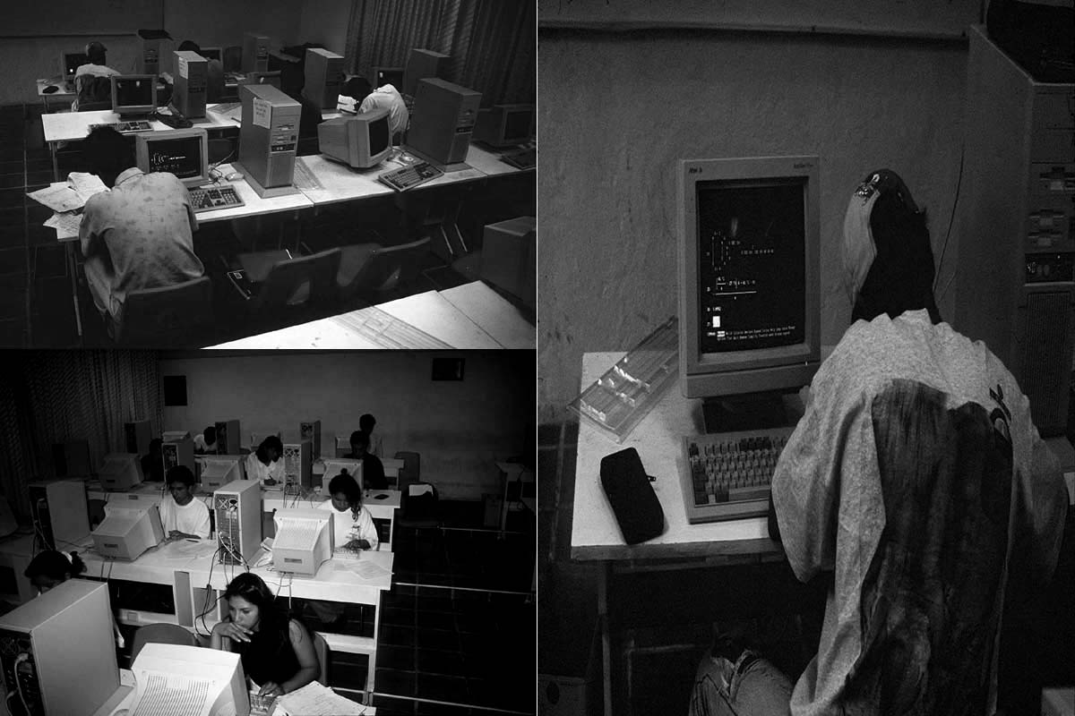
Figure 6
If there are lots of students or its hot, students can work outdoors but near to the “Didactic Classroom”. This was an initiative from the students. This can be seen in Figure 7. The fact of making the exams in this room forced us to schedule the exams for Saturdays or even some for some Holidays (for example the Sundays or first days of vacation) in this way you have outdoor space and you ensure that the Classroom is not busy.

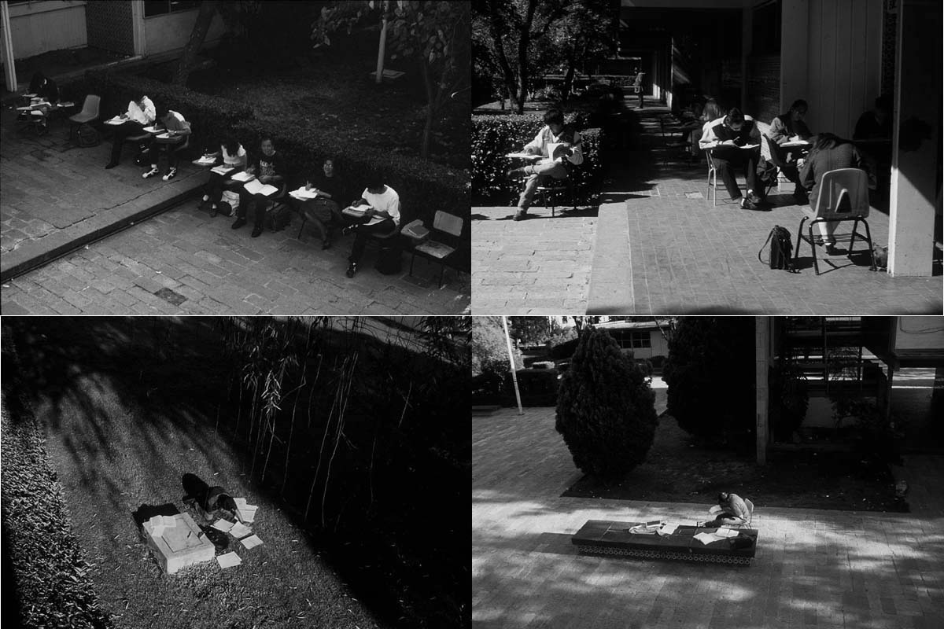
Figure 7
Another students' initiative was to take to the University their own computers like it can be noticed in Figure 8, in this way some extra computers are connected in neighbouring classrooms (with the advantage that no classrooms are busy). This helps to lower the leverage upon the hands-on-computer time in the "Didactic Classroom". These students have an advantage upon those that don’t take their computer since they have access to it almost at all the time the exam lasts (just 2 students can work on those extra computers), they know well their computer, use their standard options, their own libraries, their previous work and routines, and so on. By the other side this also helps the students that don’t take their computer since the availability time for a computer in the "Didactic Classroom" increases. Some of them even take printers since the results from the exams can be delivered in a printed format (for example in the case of Derive, where each one of the steps taken by the students can be traced, the writing is clear, and a justification for most complicated steps is asked for the students). In this cases, the exam is a mixture of an ordinary paper exam with other pages with printed results from the computer. In the case of graphs they must translate it to paper in the same way that students who don't have a printer in exam.
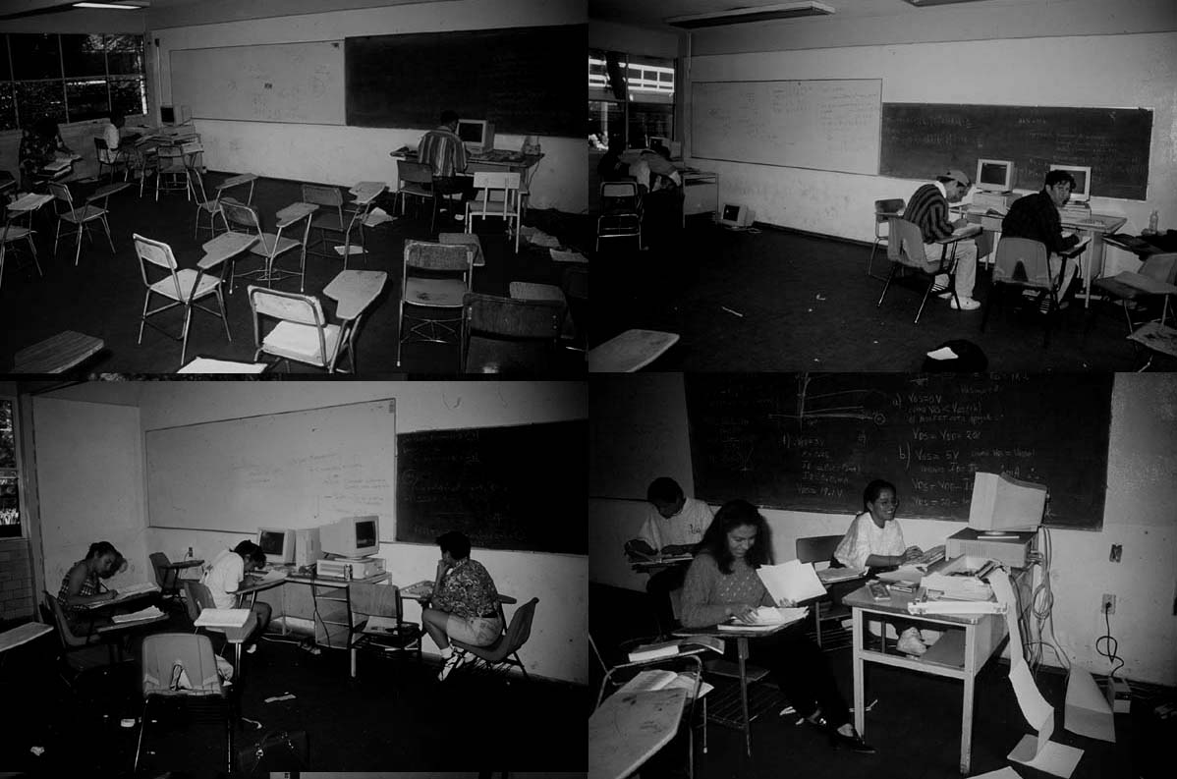
Figure 8
Of course, some time there are lots of students and there are not enough classrooms for them to hook up their computers. Themselves will solve the problem using extensions and connection plugs from the hallways as in Figure 9. When the professor arrives with the exams, the students are all set up since they’ve done it previously, setting up a kind of Computer Center using all space available. Some students take laptops.

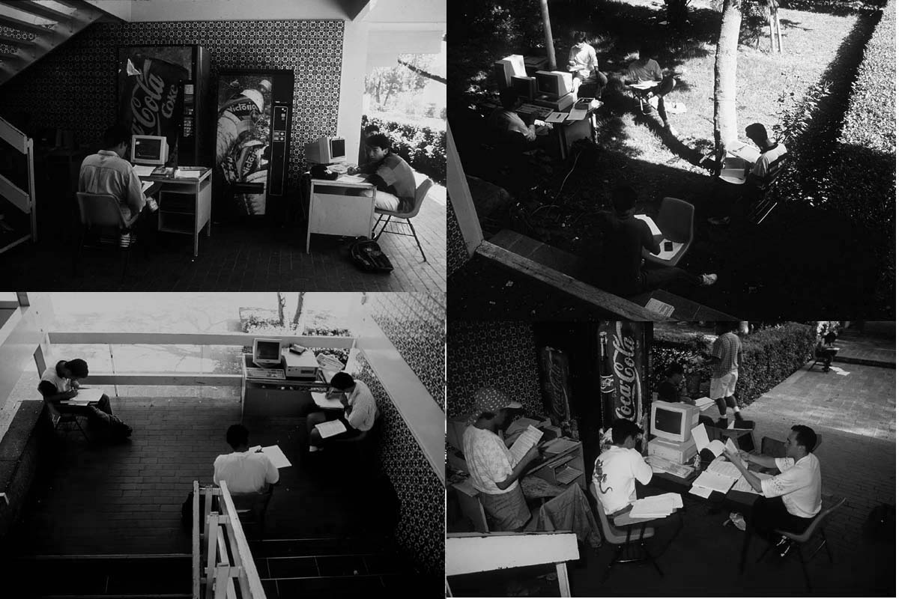
Figure 9

Some changes in teaching and in learning styles
Really, the examinations changes induced by the use of information technology form a part of global changes in teaching and learning styles. I resume here only four of them not pretending going to deep.
1. Students' acceptance for the use of information technology.
A consistent percentage of lessons take place in the “Didactic Classroom”, up to 40-50%, depending on the type of course. In these type of lessons, the teacher is no more the only center of attention because for a particular student there is also a monitor and the working group with which he/she has to negotiate the meaning of the software outputs. In general, students like better math lessons when using the computer (frequently when the lesson finishes students complain because they want to continue working on the lesson) as Böhm (1994) and Soto-Johnson (1998) have also observed, according to my students comments the liking extends when using the computer also in examinations.
2. Blind trust
Zhao (1998) alerts against the dangers derived from blind trust (in that paper it’s possible to see some examples of software pitfalls). Related with this problem exists the problem of the assessment of the rational use of information technology which takes us to recommend that both, in lessons or examinations, some questions proposed to students be of the type that the software cannot solve or cannot solve automatically, or such questions that is simpler to solve manually. For example, an intermediate step for an examination question demanded the transformation of the following equation a=$\frac{\text{ln}(P_{0}−P_{1})}{t_{1}}−\frac{\text{ln}(P_{0})}{t_{1}}−\frac{\text{ln}(P_{1}−P_{2})}{t_{1}}+\frac{\text{ln}(P_{2})}{t_{1}}$ in the equation a=$\frac{1}{t_{1}}\text{ln}\left[\frac{(P_{1}−P_{0})P_{2}}{(P_{2}−P_{1})P_{0}}\right]$, this kind of operation was very easy in a "paper-and-pencil environment" but some students introduced the first expression to Derive who answered a=∞SIGN(t), other students declared positives the variables P₀, P₁, P₂ and t₁ to obtain a= in this situations students that use software in a blind trust way will be loosing points in the examination, either because they loose hands-on-computer time entering data that is easier to process by hand, or because of the software output interpretation.
3. Not sequential tests.
In traditional exams, is common that students solve them in a "sequential way", this is, they try to solve a complete problem before continuing to the next one. Just because a student decides to stop the solution of problem a and starts solving problem b to return later to problem a (maybe after trying problems c or d and so on) does not implies that is not solving the examination in a sequential form because changing from a to b is determined by not knowing what else to do and the change comes while more ideas arise.
In previous paragraphs I stated that in computer-based examinations students are forced to solve problems in a "parallel form" because of the conditions in which the examination is applied. This means that a students has to stop in the solution of a problem not because of a lack of ideas but because computer availability, he/she stops in the solution of problem a while waiting for a computer that is being used by another student, so he/she starts solving problem b, c or d, and so on. Usually, because of time availability, a student returns to manual procedures after using the computer instead of solving completely each problem, and this behaviour repeats several times during the examination.
This is what I call not sequential examination, process that requires a greater effort, a better use of concepts and mathematical skills and a good control in the use of technology.
4. More creative and independent student performance.
Several authors from different countries have pointed out about the positive influence that information technology has on students independence and creativeness: "The use of computer algebra systems results in more independent productive pupil activity" (Nocker, 1996), "to give students an opportunity to independently investigate … in order to gain a better understanding of their theory and applications" (Spurr & Vogt, 1994), "this allows for students to explore and investigate the subject independently" (Hill & Keagy, 1997) "Different representations allow students to visualise mathematical situations and to solve problems individually according to the different ways of how students learn and understand mathematics" (Aspetsberger, 1997).
With my experience, these students' independence and creativeness are reflected even in exams in such a concrete ways: in many situations (and absolutely independent from teachers) they program their calculators, create their own utility files or adjust the files supplied by teacher, use the software in an innovative ways and so on. All of this is a very valuable experience of collective learning.

Practical and institutional obstacles
We can concentrate the global process of using information technology in regular exams (further than the regular lessons imply) in three phases: exam design, examining and revision. This is only a part of the process of integrating information technology in Math Education where many practical and institutional problems related with the continuous use of information technology arise. These problems may be such that become an obstacle leading teachers to reduce significantly or even give up the use of information technology.
For example, Artigue (1997) points that the integration of new technologies seems to be in a vicious circle where difficulties tend to maintain the educational system in the "militant pioneers" phase. In this phase, the system survives the integration or can develop itself into a non-receptive system wherefore many problems related to the integration are underestimated or they may hide important epistemological, cognitional and institutional problems. The same research also points material and institutional restrictions as possible causes for the lack of integration in the teaching with Derive.
Some of these problems are:
1. Lack of resources in schools for the acquisition of hardware, software and specific bibliography (books as well as research journals); for creation of appropriate infrastructure and technical support; and so on.
2. Teachers' training programs.
3. Social conditions that do not allow the students to have appropriated access to information technology outside the school.
4. Harassing practices from colleagues who are against the integration of information technology.
5. Institutional policies that stop the use of technology in the exams and as a consequence also stop its use in regular lessons.

What think students about technology-supported examinations?
From the beginning of my experience when a computer-based course is finished always I request my students to give a write global opinion about the course with simply and open four questions: what do you think about the content of the course? What do you think about the methodology used? What do you think about examinations in the course? and can you give some additional general comments about the course? Naturally, these questions aren't part from any research but they have the scope of exploring the territory of students opinions in an informal way, for these reason, optionally they can give their opinions in an anonymous way.
It's very interesting to know the students' answers because their comments and suggestions turn on a valuable material in the integration of information technology redesign global process. Here I present a very brief selection of opinions, they speak by its own about some of the aspects discussed in previous paragraphs, they speak about situations pointed out by teachers and researchers and show a students' personal reflection about it's own actions.

- "Thanks to computer is much more easy to do many different exercises changing some parameters. Therefore I understand why you can do a great variety of different exams" [J. Antonio, 94];
- "For me, doing math with computer was very useful for other courses, furthermore I believe that it's a so powerful tool because it allows you to study much more topics than when you don't use it" [Horacio, 97];
- "About the use of computer I think that it was a good idea at least for the following two reasons: I don't know very well how to derivate and integrate manually because in my former courses we did a very scarcely use of them, then I think that if I should get another course without the use of software I should didn't pass. The second one is that we studied topics in a much more deep way because we delegate to computer many calculations, this is, we can solve much more complex problems, in much less time and devote much more time to understand what are we doing" [J. Alberto, 98];
- "I like very much study with Derive, really is astonishing and very useful for don't fight against big calculations, some times they are so complex that don't permit you understand the essence of topics. It should be a good idea if many of our professors should demand us to put hands on information technology, really it's very interesting, very easy and useful" [Jesús, 96];
- "For me, the use of information technology implied a very drastic change in my study method, for me implied to leave behind old study methods, change toward a more dynamical and much more active ways of doing math, lessons and examinations were much more fresh, fluid. However, at the beginning, as usual, these changes are very hard, but after an adaptation period to the new system, things turn much more interesting and funny" [J. Daniel, 96];
- "Even more, beyond maths, I learnt a little bit about using a computer, Before I didn't have a good relation with it, we used to fight so often, but in the end, after spending some time with Derive software, I found it so cute " [María, 95];
- "First I believed it was very frightful doing examinations with a computer, but now I think it’s a good idea to use Physics and Maths software because it avoids you from wasting time in unnecessary stuff" [Edgar, 94];
- "First I believed it was kind of extravagant doing so huge examinations, but then I realized that by using software I could simplify many tasks" [Carmen, 97];
- "I think that using a computer helps us to study more difficult differential equations. If we wouldn’t have used it, our knowledge would be even more restricted" [Anonymus, 97];
- "In examinations my problem was the time because I'm so slow with the computer (sometimes because of my slow-pace writting and many times because of keyboard mistakes I make), and then for me examination time was very short" [Anonymous, 98];
- "In this course evaluation method was very different to others not only because examinations took place on Saturdays or Sundays (allowing a longer time for us to use the computer) but mainly because examinations included theory, methods, applications and modelling issues" [Giovanni, 97];
- "As for me, it really fascinates me the use of such a powerful tool as the computer, because it saves time you can use to go deeper into different items without taking that much care about Differential Calculus, just trying to calculate derivatives, integrals, reducing matrices and so on. For me it is great to know it exists such a powerful math software as Derive, which allowed me to create my own files to ease even more the job" [Anonymous, 98];
- "I compared this course with others on the same subject and I discovered that we followed a very different order and that in those courses examinations were extremely easy (well, if we used the computer)" [Anonymous, 96];
- "The use of software is very important to plot functions because it gives you an idea of what happens in a certain time period, which by hand would be quite more difficult, slow and susceptible to mistakes. I mean, it would be less reliable " [Mario, 95];
- "Concerning examinations, information technology changed for us the difficulty of integratig, deriving, evaluating and so on because of how “simple" (??!!?) it is to set up a problem, adjust something you didn’t know about but which could be resolved somehow. I mean, we were constrained to think and make an effort to study more general ideas and apply them to particular cases, as the exam questions and tasks assessments" [Oscar, 98]

Final remarks
This experience set up a very important basis for a second step in my University: the beginning in 1996 of a series of training workshops to in-service and pre-service teachers about the integration of technology information in Mathematics Education.
I really think that the multiple and cumulative consequences of the integration of information technology in Mathematics Education can only be thoroughly evaluated over a long period of time and after continuous experiences in regular courses that include examinations.
During these years I have not witnessed a significant change in the percentage of approved students in groups using information technology with reference to those who don't use it. The main cause of this phenomenon could be that although the use of software helps to solve some questions, this help is evened with the examination design that leads to more complex examinations from a conceptual point of view. However, we should not underestimate the inherent difficulties due to the student's necessity of organising an adequate combination of paper-and-pencil tasks with information technology tasks in a fixed time (namely, the examination time).

References
artigue m. (1997), Le logiciel ‘Derive’ comme revelateur de phenomenes didactiques lies a l’utilisation d’environnements informatiques pour l’apprentissage. Educational Studies in Mathematics, n. 33, 133-169.
aspetsberger k. (1996), Investigations on the use of DERIVE for students at the age of 17 and 18. The International DERIVE Journal, n. 1, 57-72.
bennett g. (1995), Calculus for general education in a computer classroom. The International DERIVE Journal, n. 2, 3-11.
böhm j. (1994), Linear programming with DERIVE. The International DERIVE Journal, n. 3, 46-72.
BUCHBERGER B. (1990), Should students learn integration rules? Sigsam Bulletin 24, n. 1.
drijvers p. (1998), Assessment and New Technologies: Different Policies in Different Countries. The International Journal of Computers Algebra in Mathematics Education, n. 2, 81-93.
elia m., galizia m.t. & mascarello m. (1995), From Fourier coefficients to Fourier transforms and DFT: A computer-aided path with DERIVE. The International DERIVE Journal, n. 1, 83-97.
hill r.j. & keagy t.a. (1997), Linear algebra with DERIVE. The International Journal of Computers Algebra in Mathematics Education, n. 2, 141-159.
kokol-voljc, v. (1999), Exam questions when using CAS for school mathematics teaching, Proceedings of the ACDCA 5th Summer Academy, Gösig, “ACDCA (Austrian Center for Didactics of Computer Algebra)”. (1999). http://www.acdca.ac.at. (19/03/00).
kutzler, b. (1999) “The Algebraic Calculator as a Pedagogical Tool for Teaching Mathematics”. (03/08/99). http://www.kutzler.com/bk/a-pt/ped-tool.html. (14/03/00).
mingham c. & hood d. (1995), The application of DERIVE to Fourier Analysis and the design of digital filters. The International DERIVE Journal, n. 1, 99-114.
nocker r.j. (1996), The impact of DERIVE on classroom methodology. The International DERIVE Journal, n. 1, 73-95.
rothery a. (1994), Re-organising introductory calculus using computer algebra. The International DERIVE Journal, n. 3, 27-33.
soto-johnson h. (1998), Impact of Technology on Learning Infinite Series. The International Journal of Computers Algebra in Mathematics Education, n. 2, 95-109.
spurr m.j. & vogt r. (1994), Vector Fields with DERIVE. The International DERIVE Journal, n. 2, 55-70.
townend m.s. (1994), Introducing the Convolution Theorem through DERIVE. The International DERIVE Journal, n. 2, 39-54.
zhao y. (1998), Blind Trust in Authentic Mathematical Tools in Mathematics Education. The International Journal of Computers Algebra in Mathematics Education, n. 3, 161-173.

