Calculator modulated arithmetic in elementary school

Tatjana Hodnik, Faculty of Education, University of Ljubljana

Introduction
Let me start this paper with Hopkins's idea (1976) who says that: In the Phaedrus Plato has a short discussion on the value of reading, which was at the time just coming into vogue. The tradition before was oral - people memorised stories and recited them. One of the participants in the dialogue expresses the fear that the coming of written materials will lead to the decay of the ability to memorise and recite works.
He was quite right, but a lot has also been gained: the amount of literature has been increased.
In comparison with calculating, we are facing nowadays the same dilemma: Shall we allow students to use calculators in learning mathematics? Will mathematics understanding be lost with the advent of the calculator? What understanding will be lost? Is it not strange that we resist calculators before we know about them?...
The aim of my paper is to show that one does not have to be against the calculator to be in favour of increased understanding of arithmetic.

The Changing Role of Arithmetic

A study of currently available elementary school mathematics texts suggests that the curriculum in Slovenia is computationally oriented. Computational algorithms are nothing more than a set of rules for efficient paper - and - pencil answer finding. Although it is important for students to practice mathematical algorithms and to become skilful in arithmetic, we must be aware that skills are sufficient and useful if they are built upon understanding about how algorithms work.
For example, when I was planning a mathematics lesson about the number π, I decided to prepare an activity which would clearly illustrate the value of π. Each group of students was given about 5 different models of circles, pieces of string, and rulers. Students had to measure the circumference of a circle and its diameter and find the coefficient between these measurements. All went well until we came to division. Students had problems with dividing two decimal numbers, for example 14.3 ÷ 4.6. Many of them did not know how to begin, or why 143 ÷ 46 is the same as 14.3 ÷ 4.6, and all these happened after many hours of computational drill and practice. This lesson ended without learning about the number π, we forgot about the activity and we spent the rest of the lesson on "refreshing" division with decimal numbers. So, it is not always the case that students do not know when to divide, it is even worse if they do not know how to divide after so many hours of practising that algorithm.
I believe that the definition of computation must be broadened and we must become more effective at teaching computation by shifting from a computationally based curriculum to a conceptually oriented curriculum using the calculator as an instructional tool, and by eliminating the teaching of complex computations in the elementary school (Wheatley, 1980). For example, dropping long division could create time to be devoted to application and problem-solving where the focus would be on when to divide, not how to divide.
Arithmetic itself can be learned as a powerful mathematics topic, not just a tool to assist in learning other mathematics topics. We should allow teachers to approach and develop topics of the existing mathematics curriculum in new ways.
I believe we have to think about Coburn's suggestions (1989) of paper-and-pencil skills to be deleted in primary school:
• Written computation to find sums and differences with whole numbers larger than 999 and products with numbers larger than 99. For example, 388 × 78, 3421 + 4563 + 4388.
• The standard algorithm for long division with two-digit or three-digit divisors. For example, 24356 ÷ 65
All three methods of computation: written computation, mental computation (also estimation), and calculator computation should relate to conceptualisation and problem solving. All computations should be equally important. As Wheatley (1980) suggests we should insist on mastery of basic facts, we should stress the concepts of addition, subtraction, multiplication, and division, estimation and mental arithmetic.
Will children learn to compute better given the new definition of computation with its reduced levels of written computation? It could be agreed that the revised content will not be any easier to learn. Considering cognitive theories it could be concluded that the teaching for understanding and meaningful learning are still a major ingredient in a high quality program of instruction.
As mentioned before, all methods of computation (written, mental, and calculator) are equally important in learning mathematics. In our mathematics curriculum written computations are the most important, mental computation is encouraged but the answer to the question "Should calculators be used in the mathematics classroom ?" is no. It has not been written much about calculators in elementary school and no research has been done in Slovenia in this respect. I believe that the main reason for not including calculators in elementary school are subjective teachers’ theories about learning with calculators. We can see the statement “too many teachers have doubts about using calculators in elementary school” written also in our curriculum for nine- year elementary school which came out a year ago, and calculators in the new curriculum are recommended in Year 6. It is also very precisely stated that a calculator can be used only as a tool in a restricted frame but not as a cognitive tool. We can read in our new curriculum of 1999 that the role of a calculator from Year 6 onwards is to assist learning other topics in mathematics, stereometry for example,. The authors promise also a research on appropriateness of using calculators in Years 6 and 7. There is no question about using calculators in Years 8 and 9.
There is also no question about using computers in Year 1, for example. We all believe that our six years old children will benefit in mathematics if a computer is used in a mathematics lesson. For example, we have no arguments that children learn about orientation in space when performing orientation in space with a PC (solving tasks as: put a cat behind a tree, put a bird above a cloud...). We are not afraid that children will not benefit or maybe forget to move in space. Why are some teachers and experts in education so positive about using computers in primary mathematics lessons? And why are most of our teachers and experts ‘afraid’ that children’s understanding of mathematical algorithms will be lost if we allow them to use calculators? "What understandings are involved in doing arithmetic computation with pencil and paper?" (Hopkins, 1976)
Will our children become dependent on calculators? It is also possible that children are dependent on written algorithms. "A child who multiplies 300 by 122 using the traditional paper-and-pencil algorithm is dependent on written computation." (Coburn, 1989)
My study of children’s understanding arithmetic algorithms in Year 4 showed that many children are dependent on written algorithms. For example, in a group of 27 children, 5 children used written algorithm for 25×2, 6 children used written algorithm for 115×10, 5 for 200×5, 15 for 101×8, 7 for 2000×4, 7 children calculated 300×60 as

300×60
18000
0000
180000

and 12 children used the same method for calculating 980×80. For this group of children a test to probe their understanding of basic skills in arithmetic, pattern recognising and ability to estimate at the end of Year 4 has been designed. The results showed that a calculator is of no use if children lack understanding of basic concepts in mathematics, and that drill and practice do not guarantee success in arithmetic.

Should Calculators be Used in the Mathematics Classroom? Evidence and Opinion from Around the World
The idea of using calculators in the mathematics classroom is one of the main areas of concern and argument particularly in the primary schools.
Wheatley & Shumway (1992) say that calculators have the potential to transform school mathematics from a procedurally dominated subject to the exciting study of patterns and relationships.
"The calculator can, of course be used in an exploratory and investigatory way, and pupils are able to use the calculator to help in constructing their own understanding of arithmetic." (Orton, 1987)
"Universal use of a calculator may shrink the curriculum in some ways but it will certainly expand the curriculum in a problem-solving direction." (Gawronski & Coblentz, 1976)
In the environment where calculators are available the emphasis of mathematics instruction can be on meaningful concept development and problem-solving (Wheatley & Shumway, 1992). The evidence shows that when students are engaged in problem - solving with calculators, they become more persistent (Wheatley & Shumway, 1992), students are free to spend more time thinking about the method they want to use, they are more willing to re-evaluate their own thinking, retrace their steps, and use different procedures (Finley, 1992). Herden (1985) presents a study in eight classes of intermediate level in Sweden, forms 4 - 6, where the pupils were supposed to use calculators whenever they could be of any use to them. This study took place during the period 1979 - 82 and it was evaluated by tests, questionnaires, interviews by teachers, and observations, and the results were the following: Experimental classes (students were allowed to use calculators) have shown better understanding in quantitative understanding of numbers, and in problem- solving.
Hembree & Dessart (1986) integrated the findings of 79 research reports to assess the effects of calculators on student achievement in terms of basic operational skills and problem-solving skills, and students' attitude toward mathematics, anxiety toward mathematics, self concept in mathematics, attitude toward mathematics teachers, motivation to increase mathematics knowledge, and perception of the value of mathematics in society. The study included 12 journals articles, 12 ERIC reports, a project report, an unpublished report, and 53 dissertations.

Distribution of grade levels in 79 studies of calculator use (Hembree & Dessart, 1986).

Results of this study:
• The use of calculators in testing produces much higher achievement scores in basic operations and problem solving. This statement applies across all grades K - 12 and ability levels.
• Students using calculators possess a better attitude towards mathematics and an especially better self-concept in mathematics. This statement applies across all grades and ability levels.
Another important issue in learning mathematics is motivation, and calculators play an important role there. The calculator as motivating factor is proved by many researchers (Sugarman, 1992; Shumway, 1976; NCTM, 1976).
Reasons for not using a calculator in learning mathematics such as that students might not be motivated to master basic facts and algorithms could be overcome by determining the ways of using a calculator in the classroom. If a student has to spend five minutes dividing 356483 832 and then has to check the answer on a calculator (few seconds), this student is convinced that "paper-and-pencil computation is foolish and that the school in unreal" (Immerzeel, 1976).

PrIME Calculators, Children and Mathematics
PrIME Calculators, Children and Mathematics: The Calculator Aware Number Curriculum (CAN) was a curriculum development project in England and Wales in the period 1986 - 1989. The aim of this project was to study effects that the availability of calculators would have on the mathematics curriculum of primary schools (5 - 11).

CAN started in 1986 with children aged 6 in about 20 classes in some 15 schools (a total of about 800 children).
The use of calculators
Calculators were used for learning the following topics of mathematics: place value, large numbers, negative numbers, decimals and fractions.
The children were not taught the traditional paper-and-pencil methods of calculations.
Calculation without a calculator
Children developed their own algorithms for addition, subtraction, multiplication, and division. Here are some of their algorithms:
(i) Addition
29 + 28
• 30 and 30 are 60. Then you take away 1 for 29, and 2 for 28. So take away 3 altogether and you get 57.
(ii) Subtraction
549 - 331
• 5 take away 3 is 2, and you make it into hundreds, so that is 200 and you add 40. 240 take away 30 and it comes to 210 + 9 = 219. 219 take away 1 is 218.
(iii) Multiplication
48 5
• Fifty times 5 is 250, and you take away 10, so it's 240.
129 × 37
• 129
129
129
129
129 100
129
129
129
129
1000 129 100 90
129
129
.
.
.
129
Petra added the hundreds ten at the time, recording them when she reached 1000. Then she added the 20s five at the time, recording them each time she reached 100. The 9s were added ten at a time, and finally she added all her subtotals.
(iv) Division
78 ÷ 3
• 20 + 20 + 20 = 60
8 ÷ 3 = 2 rem 2
10 ÷ 3 = 3 rem 1
2 + 1 = 3
3 ÷ 3 = 1 Answer: 20 + 2 + 3 + 1 = 26
Evaluating of the project
Evaluators visited classrooms regularly and talked with children, teachers and head teachers.
A quantitative evaluation:
At the age of 8+ a total of 116 project children were tested and their performance was compared with that of 116 other children chosen at random. In 28 of the 36 test items, a higher percentage of project children than other children gave correct responses. In 11 of these items, the success rate of the project children was 10 % or more higher than of the other children, and in one item, it was much as 30 % higher. In the remaining eight items, the non-project children performed as well or better than the project children. The maximum percentage by which the other children exceeded the project children was 5.3 %.
The results of the test are very encouraging, and suggest that, at the age of eight, children who worked in CAN were able to do better than other children on a general test of mathematics. The qualitative evaluation on the other hand has shown the effects of CAN on teachers and children in other aspects of mathematics teaching and learning which cannot be tested in the same way. These aspects include the attitudes of children and teachers to mathematics, the children's mathematical thinking in longer mathematical tasks and cross-curricula tasks, and the styles of teaching and learning. Here, too, the results were very positive.

Discussion
The CAN project is an example of an application of constructivist theory in the learning of mathematics. I do believe that it can not be applied in every place and every time. Teachers, researchers, parents and the whole education atmosphere must match in general ideas about teaching and learning to make such project possible and successful. The CAN project can make as believe that children can construct their own algorithms in arithmetic, although I have some questions how these algorithms help children in constructing standard algorithms. Can Petra, for example, who calculated 129×37 in her own way transfer her understanding of that algorithm to learning about standard algorithm? I do believe that to understand standard algorithms in arithmetic is very important. It is important because children need effective and economic method to do calculations. We do not want them to be dependent on calculators.

Children’s calculations with calculators: a study of Year 4 group of children in Slovenia

This section reports the results of a study aimed to assess children’s understanding of arithmetic algorithms, pattern recognising, and ability to estimate when children may use calculators. In this study, 27 children of Year 4 participated. The test consisted of 7 items, four relating to computations, and three to patterns. The main study hypothesis was that calculators are of no use for children if they do not understand how algorithms work. Each child has his or her own calculator. The study took place at the end of this school year and children’s mathematical knowledge was assessed by their teacher as follows:
2 children with grade 5 (best grade)
7 children with grade 4
11 children with grade 3
6 children with grade 2
1 child with grade 1.

The test
- Use your calculator to find the missing numbers in each of these problems.

673 × 45  26920  + | ← | 9□×28  + 784
 | ←
4□×□8  + 8 |  | 3872  +  + 7687 | ←
319_ |  | 20295

7683 : 98 = , rem 39

- Operation search. Use your calculator to find the operations that belong in the squares.

( 37 21) 223 = 1000
31 (87 19) = 2108

- Find the best estimate. Mark (√ ) next to the number that you estimate to be the closest to the actual product. Then use a calculator to find the actual answer and write it in the ring.

× | 78 | 42
39 | 260 3000  2800 340 | 160 1200  1600 120
61 | 4600 480  530 4800 | 240 2300  2500 370

4. Complete the following.
37 × 1 × 3 =
37 × 2 × 3 =
37 × 3 × 3 =
37 × 4 × 3 =
Is there a pattern? Find a result up to 37 × 9 × 3.

5. Complete this exercise by using your calculator only for the problems with C written in front of them. The calculator answers should help you write answers to the mental problems (M).

C | 79 × 1 × 9 =
C | 79 × 2 × 9 =
C | 79 × 3 × 9 =
M | 79 × 4 × 9 =
M | 79 × 5 × 9 =
M | 79 × 7 × 9 =
M | 79 × 9 × 9 =

6. Try to discover these properties as you perform these calculations.

C | 389 + 299 = |  | C | 575 - 197 =
M | 388 + 300 = |  | M | 578 - 200 =

7. Without using the division key on your calculator solve 1358 ÷ 58.

Results and discussion

Children were very motivated to work with calculators but the results showed that their understanding of arithmetic computations is very poor. Especially the first and the last items of the test were very difficult for them. In the table below we can see that children were more successful at solving 1a and 1e tasks because these tasks were almost identical to situations with paper and pencil computations. Children could not find the missing numbers and numerals in 1b, 1d, and especially in 1c tasks.

task | 1a | 1b | 1c | 1d | 1e | 2a | 2b | 4 | 5 | 7
% of correct answers | 63 | 11 | 7 | 26 | 89 | 59 | 52 | 67 | 44 | 0

Table 1: Children’s success at each item in percentages (item 3 was about children’s estimations and simple calculations with calculators - 11% of children made at least one calculation with calculator wrong; item 6 was not analysed because children did not have an opportunity to explain their calculations without a calculator)

Children’s solutions of the first item in the test can be grouped into four categories:

Task/categories | 1a | 1b | 1c | 1d | 1e
1.does not apply standard algorithm/incorrect answer | 4 | 11 | 4 | 8 | 3
2. partly applies standard algorithm/incorrect answer | 5 | 4 | 4 | 3 | 0
3. gets correct answer | 17 | 3 | 2 | 8 | 24
4. does not tackle a task | 1 | 9 | 17 | 8 | 0
 | 27 | 27 | 27 | 27 | 27

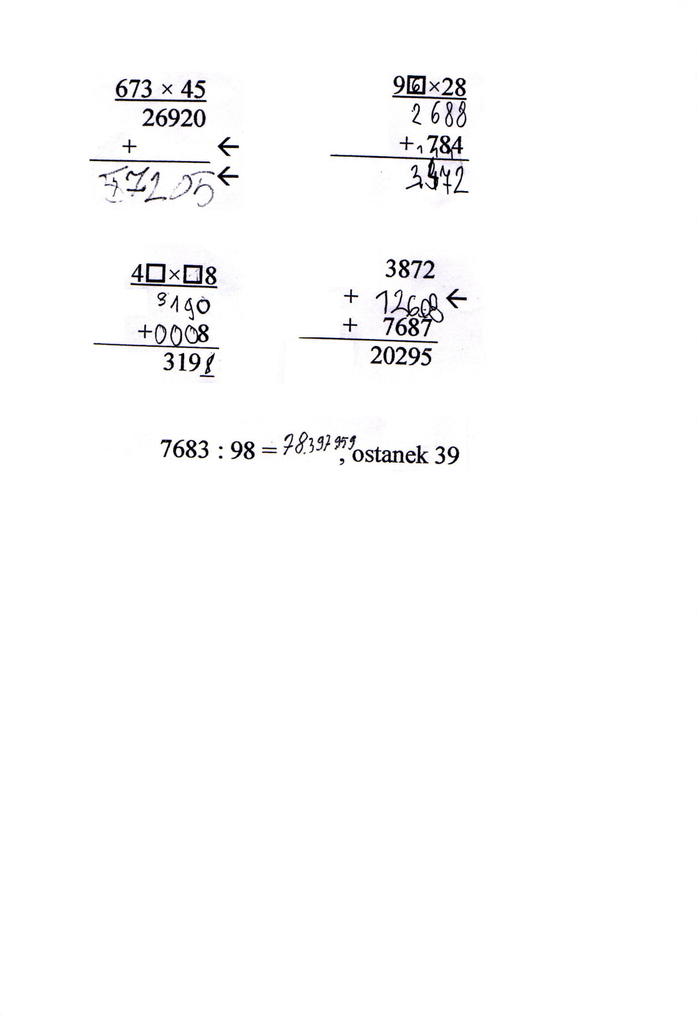
Figure 1: Some examples of children’s answers - “does not apply standard algorithm/incorrect answer”

The children were skilful in estimating (item 3 of the test), only one child’s estimation for the product of 39×78 was 260.
Items 4 and 5 assessed children’s recognising of patterns. They were happy solving these two tasks and very proud if they spotted a pattern. One boy said that he would compete with his father in solving 37×8×3 without a calculator. You can guess who is going to win! The pattern in item 5 was more difficult to recognise. Children did not use a calculator where they were asked not to use it but helped themselves with written algorithms if they have not recognised a pattern.
I used three categorises to group children’s answers about patterns:

items/categories | 4 | 5
1. sees the pattern | 18 | 12
2. does not see the pattern | 9 | 15
 | 27 | 27

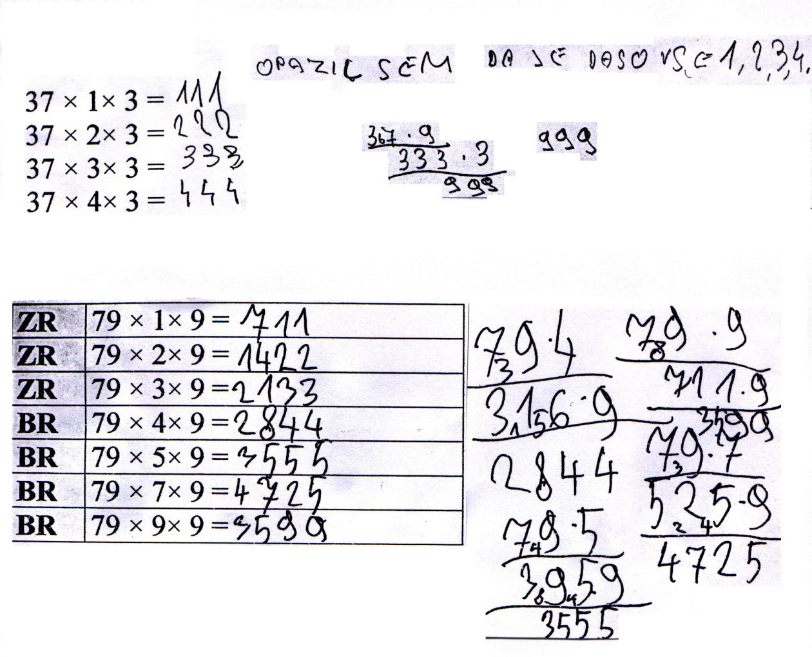
Figure 2: Some examples of children’s answers - “does not see the pattern”

Children approached item 7 very differently, but nobody got a solution or even a procedure. Children's answers could be grouped into 4 categories:

item/categories | 7
1. uses written algorithm | 7
2. uses an algorithm which is not correct | 10
3. changes operation of division into multiplication situation | 2
4. does not tackle a problem | 8
 | 27

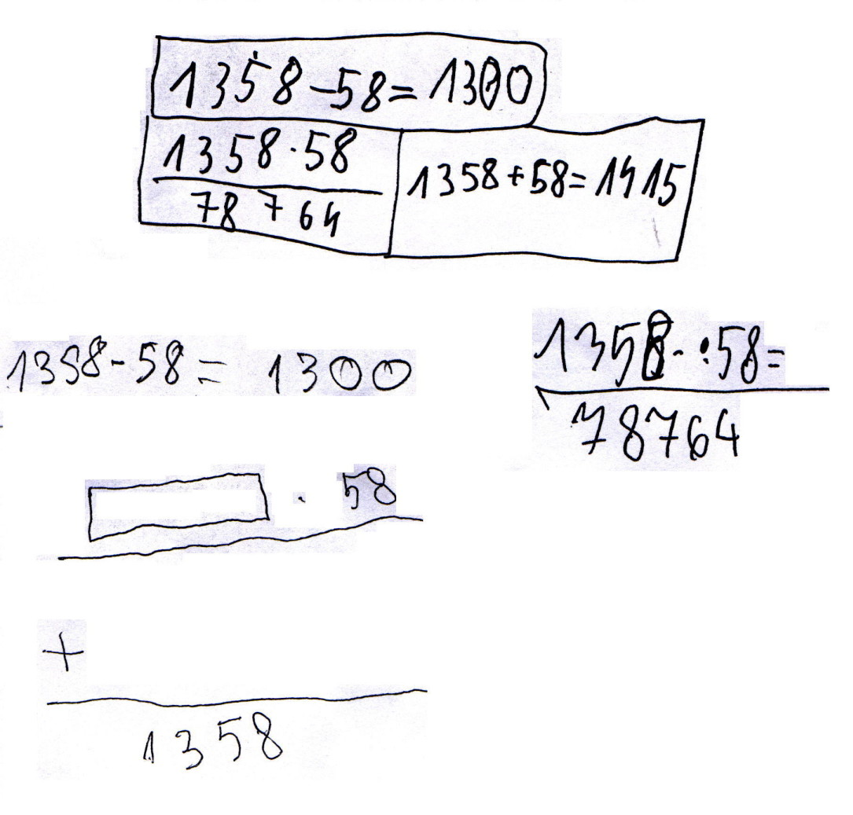
Figure 3: Some examples of children’s answers - “uses an algorithm which is not correct” (3 examples) and “changes operation of division into
multiplication situation” (1 example)

At the end of the lesson some children made an interesting comment that it was easier to do written calculations than computations with calculators.
The sample of children (27) was not representative but the results can motivate us to think that we should think about
- children’s understanding of standard algorithms
- changing the way of teaching standard algorithms
- integrating a calculator in the learning and teaching of algorithms
- assessing children’s understanding of standard algorithms with calculators.

I believe it is worth applying some ideas of this study to a bigger sample in Slovenia to research children’s understanding of computations. Not only Year 4 children, also pupils in secondary schools, and students should be involved in such research. For an illustration of what we can expect: very few primary teacher students know why we add 0 when multiplying a number by a two-digit number in written algorithm, for example 56×34, and even less students can explain why we say that in a computation 2504:3, for example, “3 does not go into 2”.

Conclusions
There are three types of mathematics curriculum with calculators: calculator-assisted, calculator-modulated and calculator-based, and research must not be unmindful of such differential roles (Bell and others, 1977).
For example, our mathematics is calculator-assisted (students can sometimes use calculators to assist calculating of volume and area of 3D shapes, for example), while the CAN curriculum, presented in this paper, was calculator-based.
In my country, I would recommend research on calculator-modulated curriculum. Together with implementing curriculum with calculators we should redefine a school arithmetic which should emphasises meaningful learning first.
Research that should determine the potential of using calculators in schools should include investigations related to the following:
• Critical analysis of existing mathematics curriculum.
• Dissemination of information about calculators both to the public and to the teaching profession (research reports, teaching materials, ideas, etc.).
• Curriculum development for the future: role of computation (mental, written, calculator and estimation), the role of problem-solving.
• Experiment and plan, finding meaningful ways to use calculators, incorporating calculators into the existing curriculum (making sure that all pupils have access to a calculator).
• New approaches to achievement testing and to assessing attitudes and other non cognitive outcomes of school mathematics instruction.
• Teacher education: training and retraining teachers in order to help them change their attitude towards calculators.

References

[1] Coburn, T. G. (1989) The Role of Computation in the Changing Mathematics Curriculum in Trafton, P. R. (Ed.) New Directions for Elementary School Mathematics, NTCM, 1989 Yearbook

[2] Finley, K. W. (1992) Calculators Aden Up to Maths Magic in the Classroom in Fey, J. T. (Ed.) Calculators in Mathematics Education, NTCM, 1992 Yearbook.

[3] Gawronski, J. D. & Coblentz, D. (1976) Calculators and the Mathematics Curriculum in Arithmetic Teacher, November 1976.

[4] Hedren, R. (1985) The Hand - Held Calculator at the Intermediate Level in Educational Studies in Mathematics 16. pp. 163 - 173

[5] Hembree, R. & Dessart, D. J. (1986) Effects of Hand - Held Calculators in Precollege Mathematics Education: A Meta Analysis in Journal for Research in Mathematics Education 17(2). pp. 83 - 99

[6] Hodnik, T. (1994) Žepni računalnik pri pouku matematike, Kongres matematikov, fizikov in astronomov Slovenije: povzetki prispevkov, Ljubljana: Društvo matematikov, fizikov in astronomov Slovenije, p. 10.

[7] Hodnik, T. (1996) Zakaj in kako vključiti žepni računalnik v pouk osnovnošolske matematike. V: Kmetič, S. Prispevki k poučevanju matematike (The Improvement of Mathematics Education in Secondary Schools: a Tempus Project), Maribor: Rotis. pp.: 201-209.

[8] Hopkins, E. E. (1976) A Modest Proposal Concerning the Use of Hand Calculators in Schools in Arithmetic Teacher, December 1976.

[9] Immerzeel, G. (1976) The Hand - Held Calculator in Arithmetic Teacher, April, 1976.

[10] Miller, D. (1979) Calculator Explorations and Problems, Cuisenaire Company of America Inc.

[11] NCTM (1976) Instructional Affairs Committee, Minicalculators in Schools in Arithmetic Teacher, January 1976.

[12] Orton, A. (1987) Learning Mathematics: Issues, Theory and Classroom Practice, Cassell Education.

[13] Shuard, H., Walsh, A., Goodwin, J. & Worcester, V. (1991) PrIME Calculators, Children and Mathematics: The Calculator - Aware Number Curriculum, NCC Enterprises Ltd, Simon & Schuster.

[14] Shumway, R. J. (1976) Hand Calculators: Where Do You Stand? in Arithmetic Teacher, November, 1976.

[15] Sinclar, H. (1990) Learning: The Interactive Recreation of Knowledge in Steffe, L. & Wood, T. (Eds.) Transforming Children's Mathematics Education: International Perspectives, Hillsdale, Lawrence Erlbaum Press.

[16] Sugarman, I. (1992) A Constructivist Approach to Developing Early Calculating Abilities in Fey, J. T. (Ed.) Calculators in Mathematics Education, NCTM, 1992 Yearbook.

[17] Wheatley, G. H. (1980) Calculators in the Classroom: A Proposal for Curricula Change in Arithmetic Teacher, December 1980.

[18] Wheatley, G. H. & Shumway, R. (1992) The Potential for Calculators to Transform Elementary School Mathematics in Fey, J. T. (Ed.) Calculators in Mathematics Education, NCTM, 1992 Yearbook.

