In this presentation I am going to report about my attempts to integrate the use of Cabri-Geometry of TI-92 in my Maths lessons. My efforts were concerned with students of secondary level one and two. First the problem of developing exam questions for Cabri-Geometry must be solved, because students only learn and consider important what will be tested by exams. For that reason we should think carefully about the way how to instruct students to use Cabri-Geometry, so that Cabri-Geometry can be part of an exam.
Basically there were four problems arising:

- The handling of the Cabri Geometry of the TI-92 is relatively complicated and a little bit toilsome.

Some pictures should show you typical problems:

The student should construct a line through the vertex of the triangle. That doesn´t seem to be a big problem.

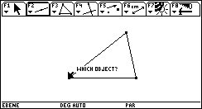

If one does not know the previous history of this construction, there will arise unexpected problems.
“Which point should I take?” the student asks.

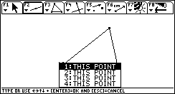

Some students produce even more hidden senseless points.
or
The student should move one vertex of the triangle to explore the properties of the circumcircle.
Do you know all properties?

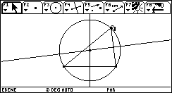

Some students find out some new properties. It is not sufficient to have the same screen as the teacher has as far as the optics is concerned.

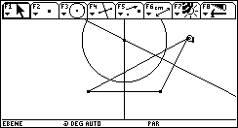

So the teacher must have enough time to help all the students to correct their constructions (sometimes in a group of thirty students more than half) and patience and patience and...........

Therefore one lesson is too short to show a construction by Cabri-Geometry very elaborately. In the regular Austrian curriculum there are never two or more maths lessons in one day. So I altered the time table for one day and the students had four maths lessons in succession. Only helpful and understanding colleagues and an open-minded headmaster can make such a change possible. First the students felt uncomfortable about having four maths lessons in succession. They were anxious about their health of body and mind. But the change of my students through this experiment is not subject of my presentation. All of you have heard about this disaster on CNN, haven´t you?
But afterward they had a feeling like an alpinist on the top of the Mount Everest.

Now I am goin to discuss the problems two and three, because these problems are connected with each other.
- If students miss a lesson, it is hard for them to learn the subject matter by themselves.

- Cabri Geometry is not permanently present in Maths lesson. The handling does not become second nature with the students.

There are often many weeks or even month between learning the handling and the date of the exam. Even students who were able to handle the geometry application forget a lot of the handling.

Students do not want do read the TI-92 guidebook (and many other users think equally) . Also many students are not able to learn the handling by studying the guidebook. There are no textbooks explaining the handling in a simple way.

So I made up descriptions of the constructions in detail as carefully as possible. Each change on screen of the TI-92 must be shown in these descriptions. Now I am going to show you parts of three examples of such descriptions. Later you will see the corresponding exam questions and some works of students.

First Example:
The construction of the circumcircle of an triangle:

At the beginning you have a blank screen . First we construct a triangle. Choose 3:Triangle.

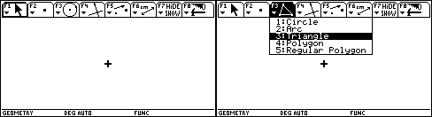

Move the construction pencil to the point , where the vertex A should be and press . The point appears as a small square on screen.

Each small change must be documented. Even the different forms of the cursor must be taken into consideration.

Immediately after pressing  we press  to label the vertex.
It is important to label the objects to have no problems with the selection of the objects.

Then we move the construction pencil by pressing the cursor pad  to the position of the second vertex.

We press , the point appears and we label by pressing .

Then we move the construction pencil by pressing the cursor pad  to the position of the vertex C. We press , the point appears and we label by pressing .

Even if some steps are very similar it is necessary to show each step.

Choose 4: Perpendicular Bisector.

Then we move the construction pencil to side c, until the construction pencil transforms into an arrow and the text PERPENDICULAR BISECTOR OF THIS SIDE OF THE TRIANGLE appears. We press . The perpendicular bisector of side c will be constructed.
It is important to wait until the text shown on the screen confirms the selection of the object we want.

Then we move the construction pencil to side a until the construction pencil tronforms into an arrow and the text PERPENDICULAR BISECTOR OF THIS SIDE OF THE TRIANGLE appears. We press . The perpendicular bisector of side a will be constructed

We choose 3: Intersection Point. We move the selection pencil by the cursor pad  to the point of intersection of the perpendicular bisectors until the text POINT AT THIS INTERSECTION appears.

We press , the intersection point appears and immediately afterwards we label by pressing U.

Second Example:
The construction of an ellipse (starting with the two foci):

By choosing /8:Geometry/3:New we start a new construction and label the figure.

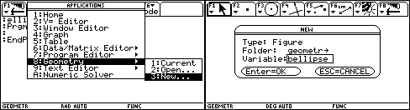

At the beginning you have a blank screen . We choose /1: Point.

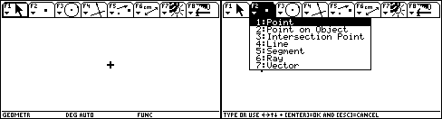

We move the construction pencil by the cursor pad to the position of the first locus. We press  and immediately afterwards we label by pressing F1.

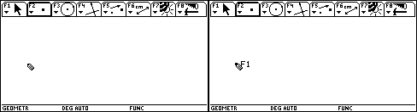

We move the construction pencil by the cursor pad to the position of the second locus. We press  and immediately afterwards we label by pressing F2.

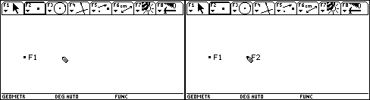

Now we will construct a segment that has the length of two semi-major axes. We choose 5:Segment. We move the construction pencil to the position where the first point of the segment should be and press .

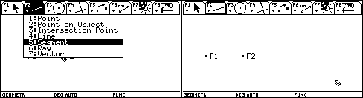

Then we move to the position of the final point of the segment and press .

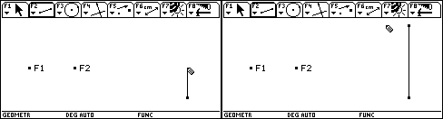

Then we fix a point on this segment. We choose :Point on Subject and move the construction pencil until it transforms into an arrow and the text ON THIS SEGMENT appears. After that we press .
It is very important that this point is on this segment.

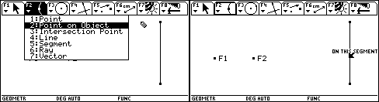

The constructed point divides the segment into two focal distances so that the sum of them is equal to the length of two semi-major axes. We choose :Compass.

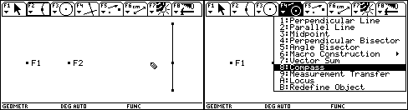

By this tool one can construct a circle given by its midpoint and radius. At first the radius must be determined by the distance between two points. We move the construction pencil to the first point of the segment until the pencil is transformed into an arrow and the text THIS POINT appears. Then we press . The selected point flashes. After that we move the construction pencil to the point that divides the segment until the pencil is transformed into an arrow and the text THIS POINT appears. Then we press . Also this point flashes.

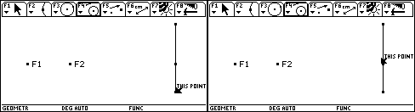

At the end we must select the midpoint of the circle. We move the construction pencil to focus F1 until the pencil is transformed into an arrow and the text THIS POINT appears. Then we press . The circle appears.

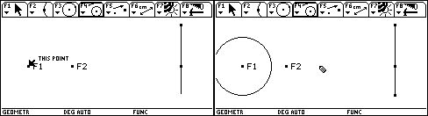

Some of the tools are complicated in handling. For example the compass tool. So the handling must be shown very exactly.

The compass-tool is still active. So we can construct a second circle. To determine the radius we select the point that divides the segment and the final point of the segment.

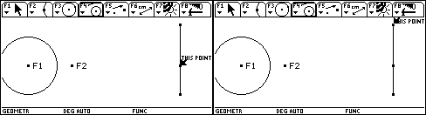

Then we select the focus F2 as midpoint for the second circle. The second circle appears.

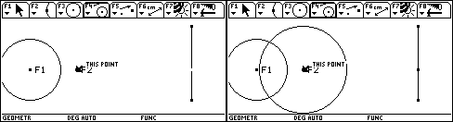

The intersection points of the two circles are points of the ellipse. We choose 3:Intersection Point. We move the construction pencil to the bigger circle until the pencil is tranformed into an arrow and the text THIS CIRCLE appears. Then we press .

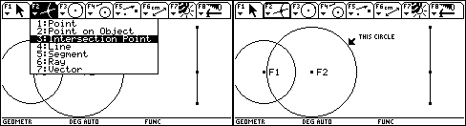

The selected circle is drawn as a dotted line. Now we move the construction pencil to the other circle until the pencil is transformed into an arrow and the text THIS CIRCLE appears. Then we press .

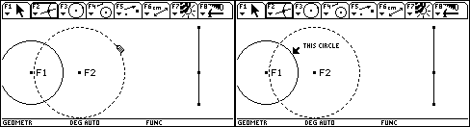

Both intersection points are marked. If one moves the point that divides the segment, the radius of the circles changes and other points of the ellipse appear. We press  and the tool 1:Pointer is active. We move the crosshair to the dividing point until the crosshair changes to an arrow and the text THIS POINT appears.

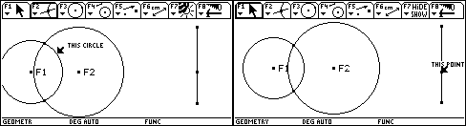

Then we press  and hold. A fist grasps the point. If we press in addition  or , the point moves along the segment and the complete construction will be changed.

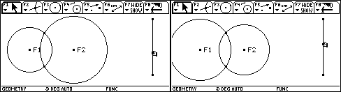

The curve of moved points can be shown. We choose 2:Trace On/Off. Then we move the construction pencil to one of the intersection points of the circles until the pencil is transformed into an arrow and the text THIS POINT appears. At the end we press .

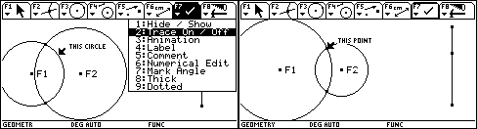

Then we move the construction pencil to the other intersection point of the circles until the pencil is transformed to an arrow and the text THIS POINT appears. Then we press .
We press  and the tool 1:Pointer is active. We move the crosshair to the dividing point until the crosshair changes to an arrow and the text THIS POINT appears.

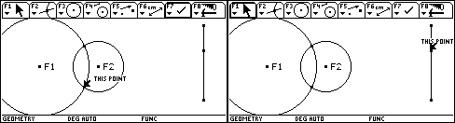

Then we press  and hold. A fist grasps the point. If we press in addition  or , the point moves along the segment and the complete construction will be changed. The curve of the selected points will be drawn.

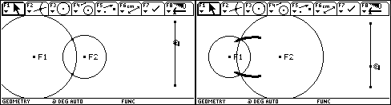

This process can be done automatically Therefore we choose 3:Animation and move the crosshair to the dividing point of the segment until the crosshair changes to an arrow and the text THIS POINT appears.

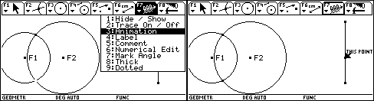

Then we press  and hold. A fist grasps the point. If we press in addition  or , the fist drags the animation spring. The farther away the spring is pulled the faster the object is moved. At the end release all keys and the animation will start.

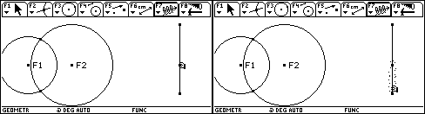

By pressing  you can finish the animation. By pressing  the drawn ellipse can be deleted.

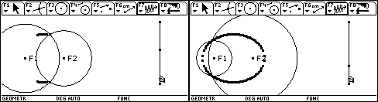

Third Example:
The graph of sine and cosine function calculated by the defintion of sine and cosine in the right triangle.
The description of this lesson is not that exact, because the students of this class were already used to Cabri-Geometry.

By choosing /8:Geometry/3:New we start a new construction and label the figure.

By pressing  F Geometry Format appears and we select for angle the option DEGREE and for Display Precision the option FIX 6.

Then we construct a circle,

afterwards a horizontal line through the midpoint of the circle.

Then we construct a point on the circle.

In the next step we plan a line through the point that is perpendicular to the horizontal line.

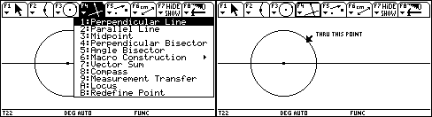

Now we determine the intersection point of the two lines.

Afterwards we construct a segment from the midpoint of the circle to point on the Circle.

A right triangle is constructed now. We measure the angle with the Angle tool that has the vertex in the midpoint of the circle.

First we must select a point of a side, then the vertex and at the end a point of the other side.

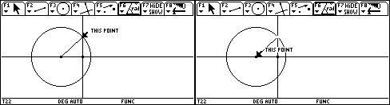

The measure of the angle appears.

By the pointer tool we move the measure to a convenient place.

Then we label the measure with the Comment tool. We move the cursor to the place we have in mind.

By pressing  a comment box appears in which we type the label.

Now the angle, we have measured, should be marked.

Again we must select a point of a side, then the vertex and at the end a point of the other side.

The angle mark appears. Then we measure the length of the hypotenuse of the right triangle.

Also this number will be moved by the pointer tool to a convenient place.

Again by the comment tool we label the number.

Then we determine the length of the opposite side and comment on the number.

Then we determine the length of the adjacent side and comment on the number.

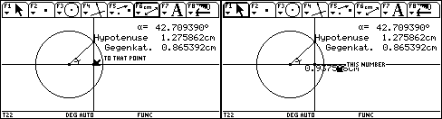

With the pointer tool we move the point on the circle, until the measure of the angle is near zero.

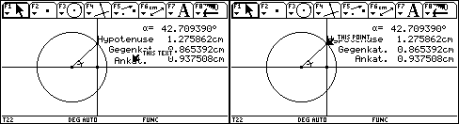

Now we transfer the measures of the angle and the sides to the Data/Matrix Editor. We choose wiht the tool  Collect Date the option Define Entry.

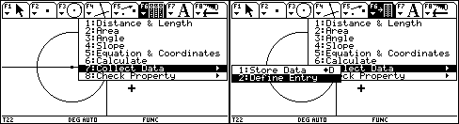

Then we select the measure of the angle and the sides one after the other.

By pressing  D the selected numbers are transferred to the Data/Matrix Editor and stored in the variable sysdata. You can see a comment in the status line.
By moving the point on the circle we increase the angle and each time we store the dates by pressing  D .

By pressing  6 we get to the Data/Matrix Editor and open the variable sysdata.

In the first column there are the measures of the anlge, in the second column the lengths of the hypotenuse, in the third the length of the opposite side and in the fourth the length of the adjacent side. We move the cursor to the title line to the cell N1, press  and type the new title anlge for the first column in the entry line.

Also the other columns get the corresponding titles. The empty fifth column gets the titel sine. Afterwards we move the cursor to the cell c5 and enter the header definition c3/c2. So in the 5th column the sine values will be calculated.

By analogy the cosine values will be calculated in the 6th column.

Then we will plot the sine and cosine values depending from the angle. We choose  Plot Setup, select Plot1 und choose  Define. We choose the following options: xyline, square, column c1 for x und column c5 for y.

By analogy we define the plot for the cosine values. By pressing  we get back to the Data/Matrix Editor.

We change to the y=-Editor and define the sine function as y1(x) and the cosine function as y2(x).

We control if the mode of angle is DEGREE and we enter convenient window variables.

Then we can see the plots and the graphs of the functions.

- How should I control the results of the exam questions by using Cabri-Geometry?

In Austrian secondary schools students have no useful possibility of printing dates of the TI-92 by computer.
Each school has an informatics-room with computers, but there is only one printer. Therefore it is not really possible that thirty students print their results during 50 minutes (length of an exam) by this printer. On the other hand I do not want to take thirty TI-92 after the exam to controll the mememories and dates that students have stored by Cabri Geometry.
So I decided to ask the students to describe in words, how they are working with Cabri Geometry by means of a special problem - nearly a composition in mathematics.

- How should an exam question using Cabri-Geometry look like!
I had in mind four possibilities.
Making a construction that was shown in class.
Making a construction that was shown in lessons, and exploring a property that was not shown during the lessons.
Making a construction that was not shown in class.
Making a construction, that was not shown in class, and exploring a property that was not shown during the lessons.
For the moment I chose the first possibility, because I did not want to overcharge my students.
Now I show you the exam questions of three tests of the last year. You will see all questions so that you can see how the questions about Cabri Geometry are included in the test. The length of time of the tests was 50 minutes. The student passed the exam if he had more than 11 points (out of 24 possible points).

First example:

Class:5B 3rd . test 18.1.2000

Group A

- Describe in detail, how one can construct the circumcircle of a triangle by cabri-geometry!
For example you can start in this way:
Choose F3/3 Triangle and determine the first vertex of the triangle!
Label the vertex by A.......

6 Points

2) Solve by the method of equal coefficients without using the TI-92 and control by the TI-92 by the command simult!
$$\begin{aligned}7x−5y=−\text{41} \\ 3x+8y=\text{23}\end{aligned}$$
3 Points
3) Solve by subtitution without using the TI-92 and control by the TI-92 by the command rref!

$$\begin{aligned}5x−3y=5 \\ y=\frac{3}{2}x−2\end{aligned}$$
3 Points
- Solve by elimination by comparison without the TI-92!
$$\begin{aligned}y=\frac{3}{4}x−2 \\ y=\frac{3}{2}x−8\end{aligned}$$
2 Points

- Draw the graph of the linear function $f(x)=−\frac{4}{5}x+1$ and determine graphically and numerically the zero and the fixed point of this function.

6 Points

6) Find the term of the linear function from which you can see the graphs in the following pictures.

4 Points

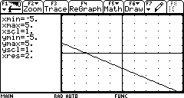

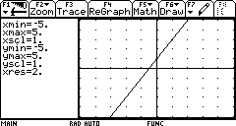
For this test students had about 12 minutes time for answering the cabri-question.

At first an example for a useful work, a nice geometry composition. I marked it with all six points.

Next a composition with some gaps. I marked it with four of the six points.
The next one is a a short but exact description. I marked it with all six points.
Second example:

Class:5B 3rd test 18.1.2000

Group B

- Describe in detail, how one can construct an ellipse by cabri-geometry using the two foci and the length of the major axes!
For example you can start in this way:

Choose F2/1 Point and fix the 1. focus
Label the 1. focus by F1.......

6 Points

2) Solve by the method of equal coefficients without using the TI-92 and control by the TI-92 by the command simult!
$$\begin{aligned}−5x+7y=−\text{41} \\ 8x+3y=\text{23}\end{aligned}$$
3 Points
3) Solve by subtitution without using the TI-92 and control by the TI-92 by the command rref!

$$\begin{aligned}−3x+5y=5 \\ x=\frac{3}{2}y−2\end{aligned}$$
3 Points
4) Solve by elimination by comparison without the TI-92!

$$\begin{aligned}x=\frac{3}{4}y−2 \\ x=\frac{3}{2}y−8\end{aligned}$$
2 Points

5) Draw the graph of the linear function $f(x)=−\frac{3}{4}x+1$ and determine graphically and numerically the zero and the fixed point of this function.

6 Points

6) Find the term of the linear function from which you can see the graphs in the following pictures.

4 Points

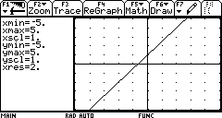

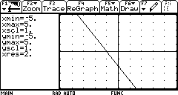

For this test the students were given about 12 minutes for the cabri-question.
First a very nice description. I marked it with all six points.
It is a really detailed description. Here you see the second page.

The second work is a very confusing description full of gaps. Only one point is possible.
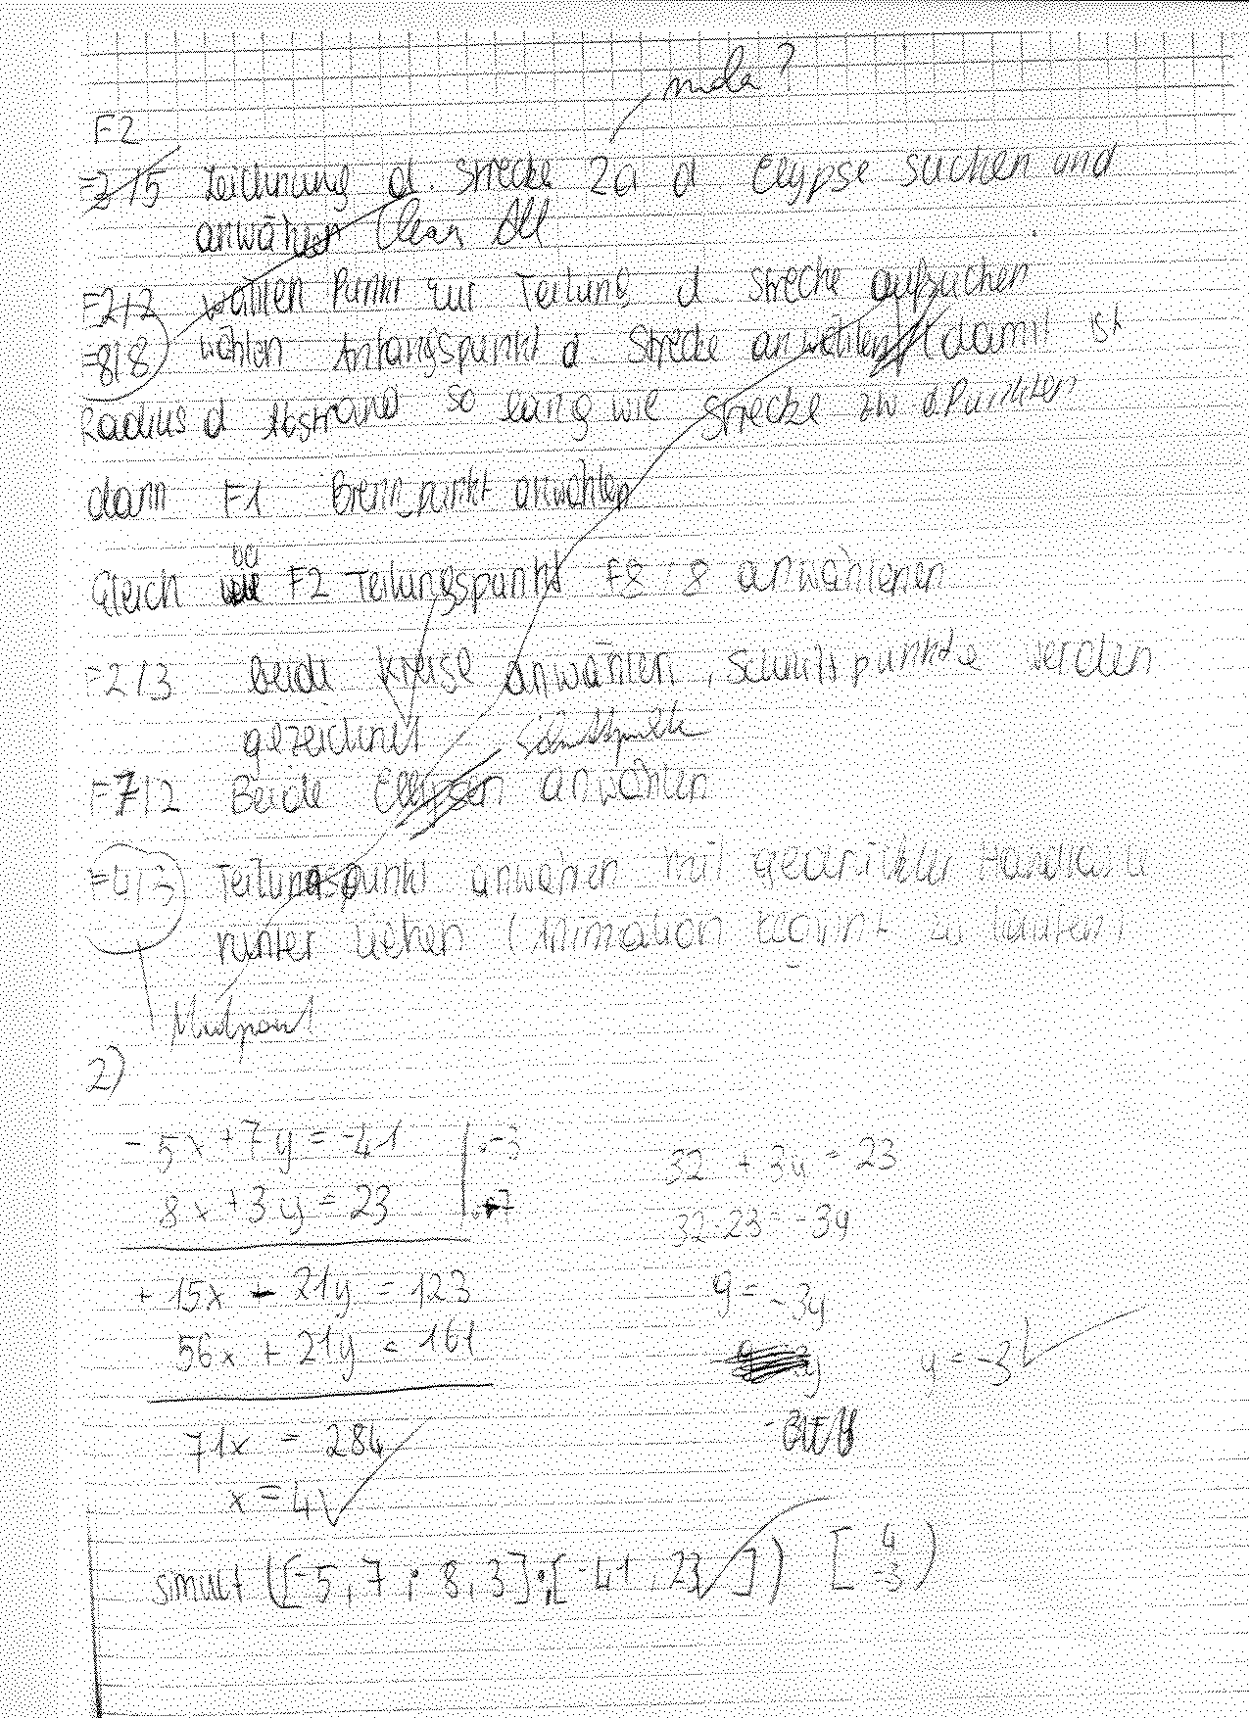
Third example:

Class: 6 2nd Test 6. 12. 1999

- Mr. Dollar takes out a loan of 15000 $ from his bank. The interest rate is 9%. The length of time of the loan is 10 years. Calculate the yearly repayment and the debts of Mr. Dollar after five years!
4 Points

- Prove in detail the law of cosines by using a picture of an acute triangle!
$$a^{2}=b^{2}+c^{2}−2\text{bc}\text{cos}\left(α\right)$$

3 Points
- Calculation of the triangle by the law of sines and the law of cosines:
Find an example for a triangle that is given by three sides!
Find an example for a triangle that is given by two angles and one side!
Find an example for a triangle, that is given by two sides and the angle built of these sides!
Find an example for a triangle that is given by two sides and the angle that lies opposite the longer side.
Construct these triangles by compass and straight edge. Calculate the other sides and angles of the last triangle!
7 Points
- Describe in detail, how one can calculate the value of sines of an angle by cabri geometry for three different measures of the angle and how one can plot the sine-function by transferring the values from cabri-geometry to the Data/Matrix-Editor! Instruction:
- Construction of a right triangle!
- Measurement of angle and sides!
- Transfer of the dates to the Data/Matrix-Editor
- Calculation of the values of sines in the Data/Matrix-Editor (make a copy of your Editor)
- Plot of the sine function
10 Points
For this test the students were given about 20 minutes for the cabri-quesion.
First example is a very clear and detailed description, but the dates of the Data/Matrix-Editor are missing and in the definition of the plots there is a mistake. I marked it with 9 points.

In the second example the description is a little bit short and the dates and the definition of the plots are missing.

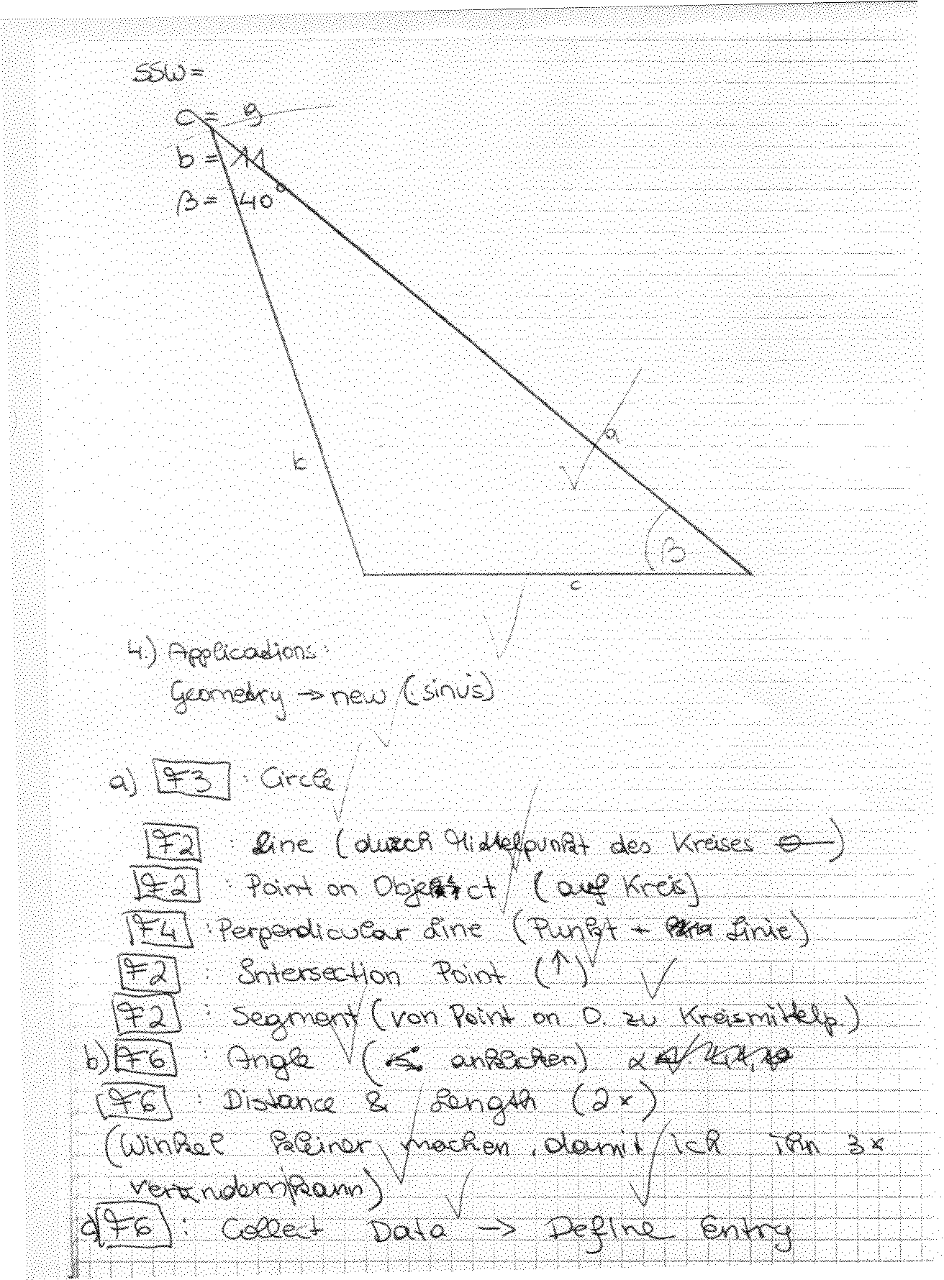

In the third example the description is very poor. There were just 3 points available.
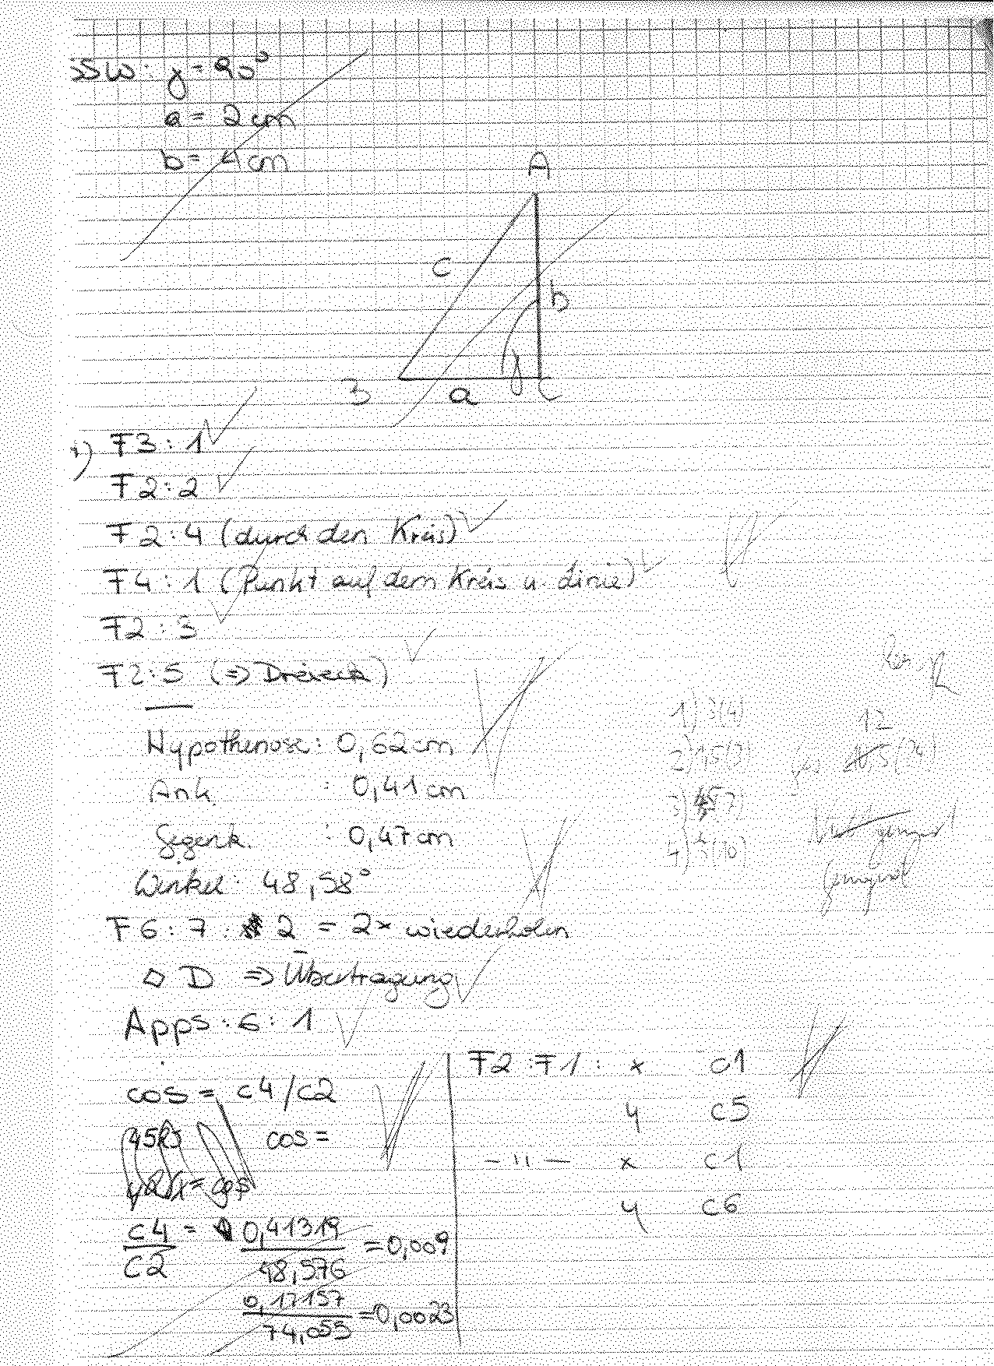

In the last example the description of the calculation of sines in the Data/Matrix-Editor is missing. I marked it with 8 points.

