AN OTHER APPROACH OF TEACHING MATHEMATICS
WITH NEW TECHNOLOGIES
Presented by Jean-Jacques DAHAN, with the help of CABRI GEOMETRE

We all try to create new exercises, new problems integrating new technologies (hand held calculators, and softwares). I think that it is possible to evaluate new abilities. In fact these abilities are nearest of mathematic activity than the abilities we used to test in the classical exercices and in actual examinations. The aim is always to do Math, but to do true Math.

1. TRY TO DO DO TRUE MATH WITH THIS BLACK BOX
The blue bold point gives the red point with an unknown transformation; here are some of the manipulations that could help us to solve this problem (for more information about black boxes look at Colette Laborde's works or presentations):
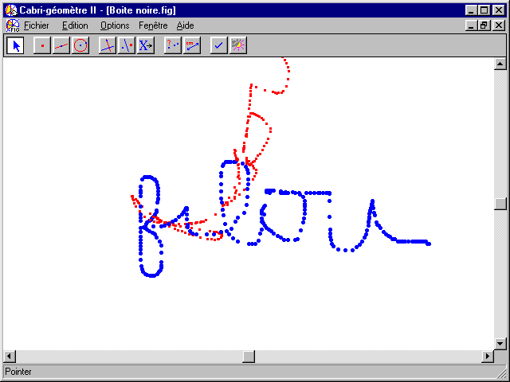 | 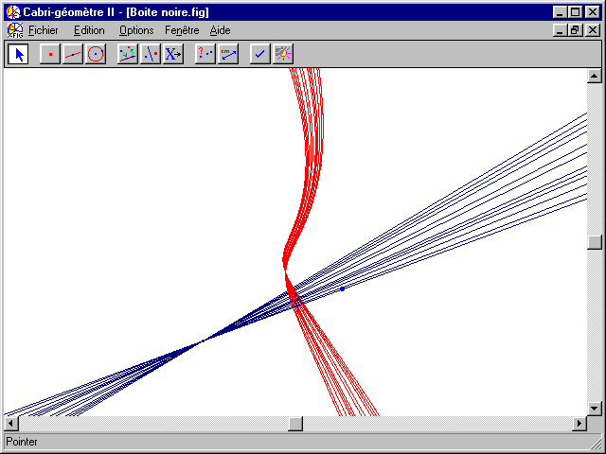 | You must now discover how the red point has been constructed starting from the blue point. It is a true mathematic activity that only begins now and that needs a lot of other tests!!!
You understand with this exemple that using new technologies needs an other approach of teaching Mathematics This approch must be a global and pedagogical approach;new exercises, new problems and new exams are the consequences of a new regulation of the fundamental links between:
The Teacher and Maths, the Teacher and the Learner, the Learner and Maths

2. About the first link (Teacher-Mathematics)
The teacher must have a real math activity when he uses NT during all the phasis of his work:
2.1. When he prepares his courses:
He must use CAS with pertinency and always with curiousity. So he will be surprised. Therefore, he will appreciate a new flavor for doing Math. Please, listen to this little story:
I was preparing for one of my student a Cabri file for his course about similar triangles; it was the first following figure where the two rays must have the same origin; but it happens an accident: M' was constructed in order that OM'/OA' = OM/OA, so I might observe that (MM')//(AA'), or:
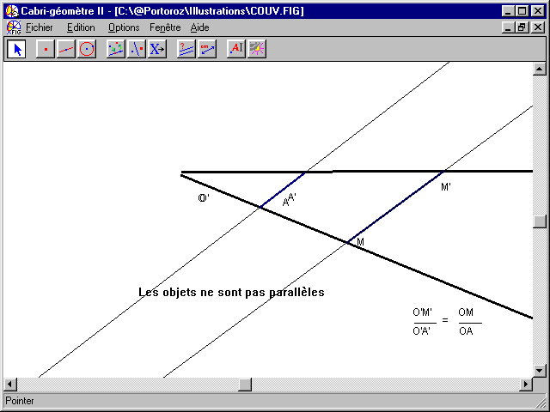  (MM') and (AA') are not parallel,because their origins are differnt | 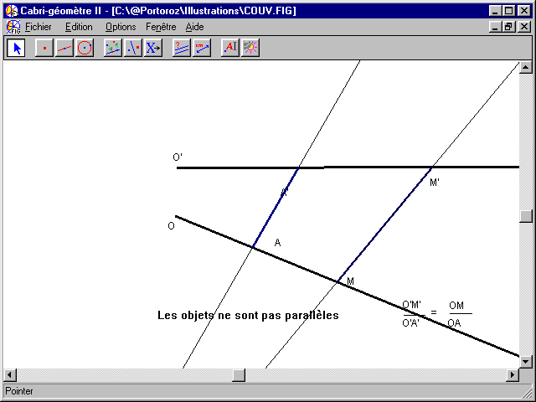  Instead of starting again the figure, I moved apart the two origins | 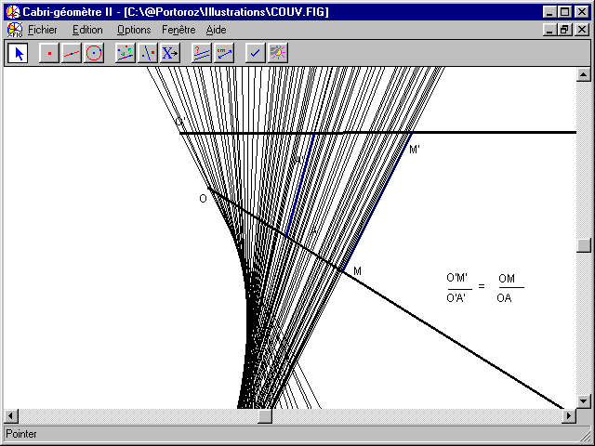  And I observe traces of lines (MM') when I drag M and a beautiful curve appears

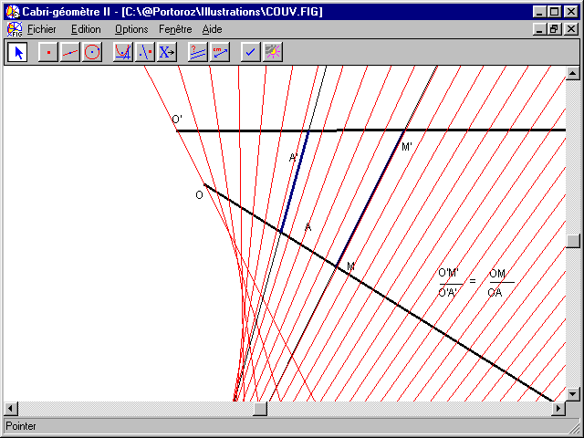  Same observations with the locus of lines (MM') | 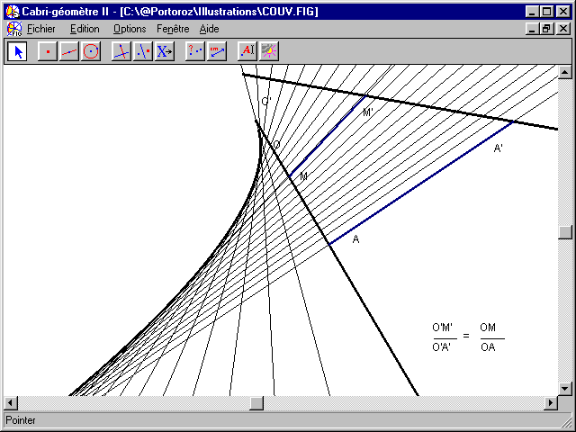  Finally, it seems here that the envelope of lines (MM') is a parabola | Here we get the cover of the book I have written in 1998 which is a ludic initiation of Cabri on the TI-92 (ELLIPSES Publishing). About this curve, it is really a parabola and I prooved it with the help of formal calculus in the TI-92. This result hides another more beautiful about five tangents to a parabola.

2.2. When he succeeds to connect Mathematics and Physics:
In introducing modelization problems and therefore in creating new problems (below I illustrate it with refraction in Optics: this is the result of my cooperation with Mathilde Arragon, Physics Teacher in Grenoble).
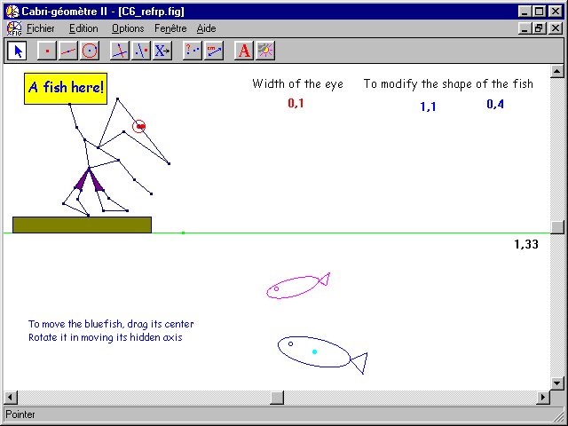  Filou looks at the blue fish in the water and he has the impression that it is the red one | 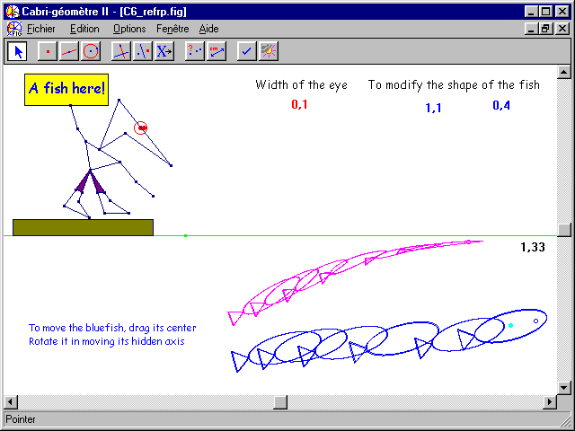  This modelization was very difficult because it needs the use of a macro created recentlly by | 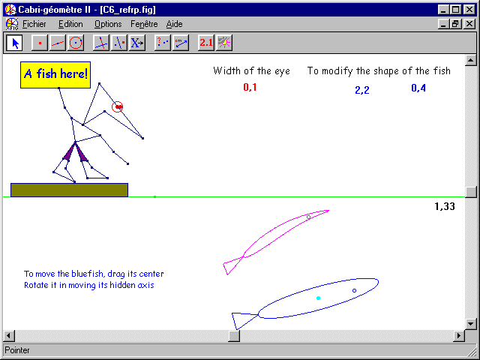  Jean-Marie Laugier, Physics Professor at Marseille University  Thanks to him

2.3. When he uses calculators in an original way
For example, when he uses the TI-83 to do dynamic géometry or to approach formal calculus. Let us create the four lists L1, L2, L3 and L4 in the data editor of our calculator after giving a value to T (below T=V =40) in the home screen.
{-3,-3,-2,-2,-3,-3,-1,-1,-4,-4,-1}→L1  { 0, 2 , 2, 3, 3 , 4, 4, 5 , 5, 0, 0}→L2 | L3 = L1 * COS(T°) - L2 * SIN(T°)  L4 = L1 * SIN (T°) + L2 * COS(T°)

Right, the first figure is presented with Cabri but it can be obtained as a statistic graph in the TI-83. The second figure can also be obtained with the TI-83 provided that we use a very short and simple program | 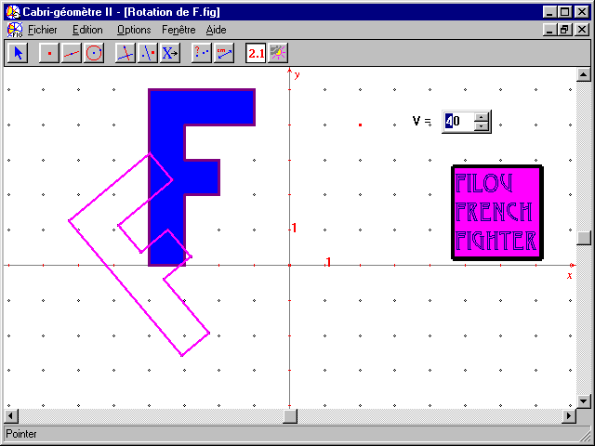 | 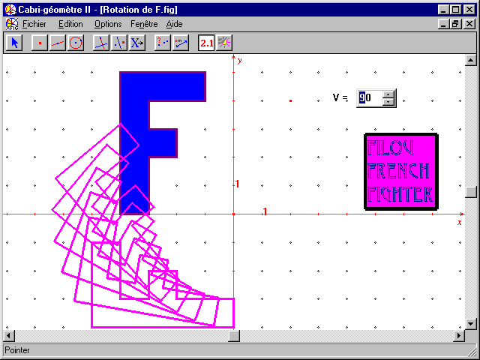

3. About the SECOND link (Teacher-LEARNER)
The new aim is to create a productive communication:
3.1.The teacher must fight to surprise, to astonish his students even in a ludic way,
Like here, when he presents Filou fencing in a lot of different positions | 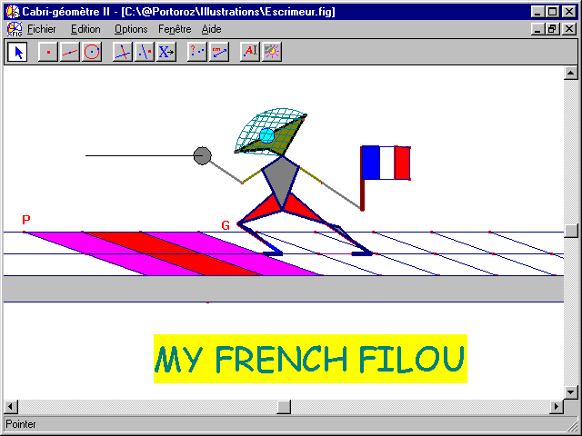 | 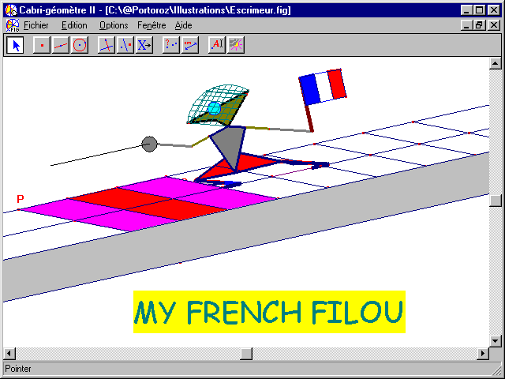

3.2. He can get their interest in showing them exemples of the power of softwares that can be a new aim for students like below when he presents spheres in parallel perspective in opposition of representations of spheres in Math books
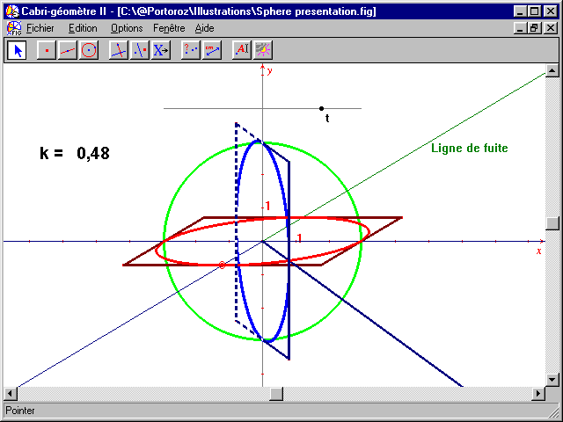 | 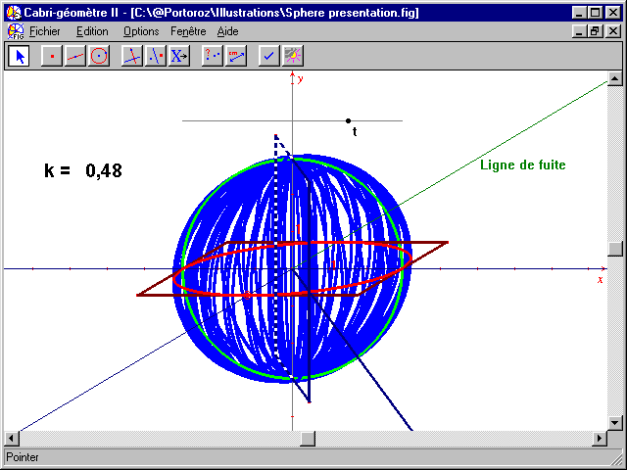 | 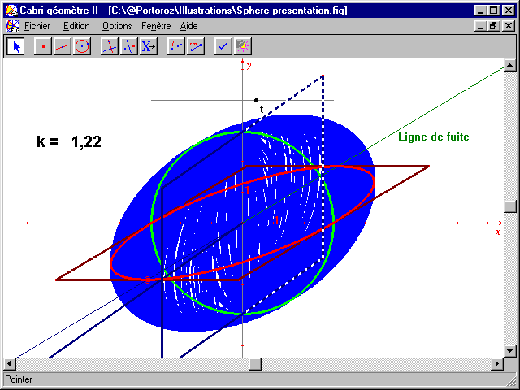

3.3.He will propose them to solve problems that needs NT and where they will use all their knowledges and not only what they have discovered last week. These problems often permit to obtain a hard devolution (involvement).
For exemple, how to constuct a Filou skiing like in the reality | 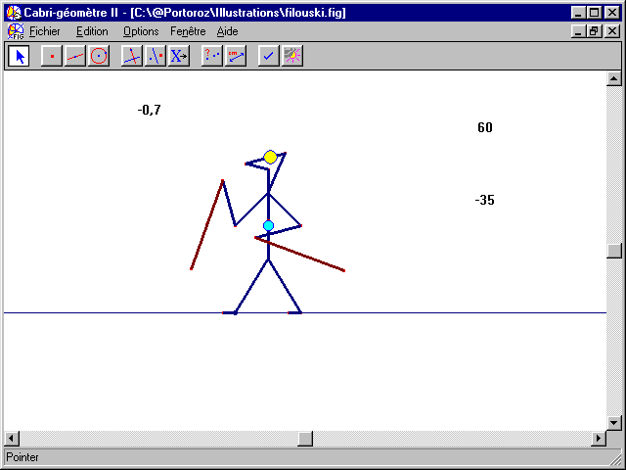 | 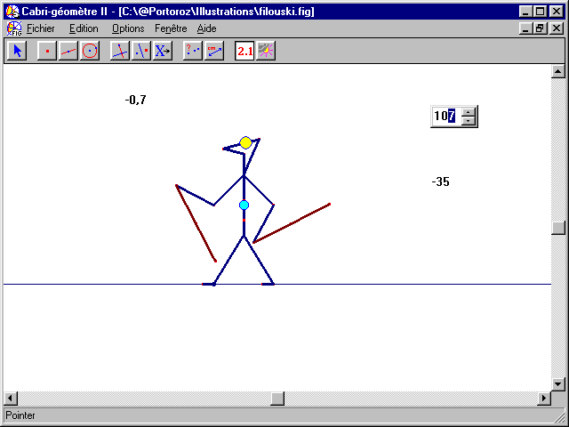

3.4. He will learn them how to use data tables for solving problems in a modern way; for example, this probleme easily solved with the data editor of the TI-83:
When a cinema ticket coasts 30F the cinema is full with 500 persons. For 1F of increasement of the ticket the number of spectators decreases of 10.  What is the ticket price giving the best receipt? | 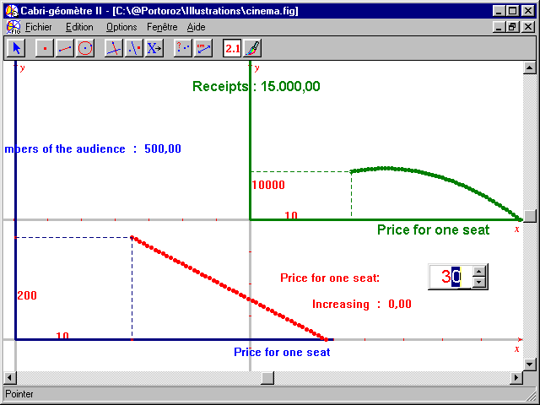 | 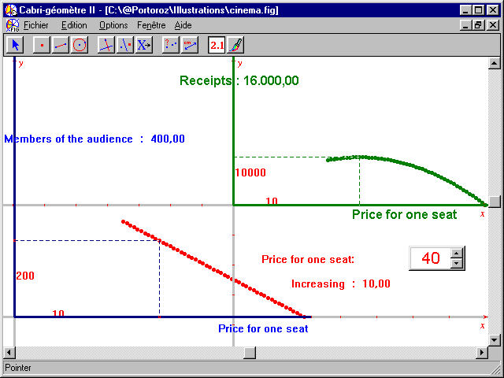

4. About the THIRD link (LEARNER-MATHematics)
The students must have challenges to win (Luc Trouche). They cannot win them in a short time; it needs weeks and it is a long way. It is not the success that can be evaluated but all the strategies that are used…. The students will decide by themselves what they want to test: how to construct a skiing Filou? How to solve the black box problem?

5. CONCLUSION
New abilities for a modern pratice of Mathematics:  To be able to elaborate stategies to solve problems; this ability contains the skills in manipulating in conjecturing in verifying in using different softares to try to proove. It is important to label this abilities in order to elaborate a CAS assessment which must be as pertinent as possible. | 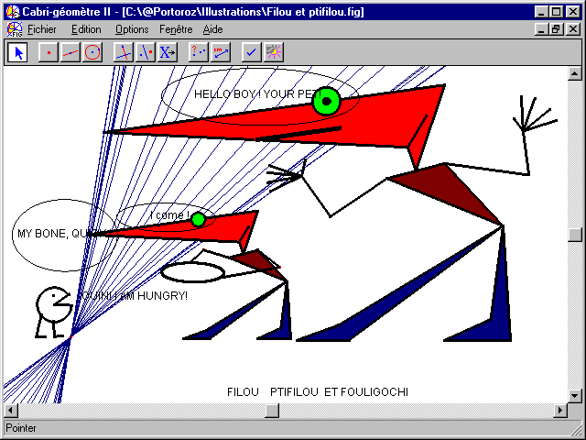
e-mail: jjdahan@wanadoo.fr
mail adress: IREM de Toulouse 118 Route de Narbonne 31Toulouse FRANCE

