Otto Wurnig, Graz (Austria)
New Ways of Assessment in CAS-oriented mathematical Education -
New Experiences, First results.

The use of computers in mathematical education in schools depends on some very important conditions. The use of the computer has to be required in the curriculum, sufficient hardware and good software has to be bought and the computer is to be admitted in oral and written exams, inclusive the final examinations. All these conditions have been fulfilled to a great extent for grammar schools, business academies, secondary technical and trade schools in Austria in the last ten years. Therefore it depends primarily on the mathematics teacher, in which way and how intensively the computer is used in mathematical education.
Up to 1990 the minimum equipment in grammar schools, business academies, secondary technical and trade schools in Austria was two computer labs, one of which always met the requirement of even large classes, where very often two students were working per computer. But they suffered from a lack of really useful software. In spring 1991 derive 2.x was bought with a general licence for all Austrian schools preparing students for university level. This led to the foundation of two organisations for mathematics teachers, the AMMU and the ACDCA.
In the winter of 1991 the AMMU (Arbeitsgruppe für Modernen Mathematik-Unterricht) began to exist. The goal of the working group was to consider, how and to which extent the computer should be integrated in mathematical education and in addition to help mathematics teachers to get new ideas and useful materials. Two publications per year were issued and meetings for teachers in mathematics, especially for business academies and secondary technical and trade schools, were organised. These schools are attended by 44% of all students prepared for university studies. In the homepage http://www.ccc.at/ammu you’ll find the latest publications and the date of the next meetings.
In the spring of 1992 ACDCA (Austrian Centre for Didactics of Computer Algebra) was founded its first chairman being H. Heugl. It was founded in order to create a forum for ongoing discussions and research concerning the use of CAS in teaching mathematics, especially in arts grammar and science grammar schools. Grammar schools are also attended by 44% of all students prepared for university - studies. Conferences, meetings and publications are intended to offer a framework for university teachers, teacher trainers and school teachers to exchange their experiences and to do research projects (Homepage: http://www.acdca.ac.at).
The activities of these two organisations are the reason, why more & more teachers in Austria allow students to use personal and pocket computers in mathematics when writing tests.
But it is not easy for the teachers, because in big classes there are often more students than computers available, not every student has a computer at home and not all lessons can be held in a computer lab. Therefore three practicable models for tests with the help of computers have developed.

Model 1: different examples for students with/without CAS
model 2: time-sharing on the same computer between two students
model 3: 50% team work alternating with 50% single work on the same computer

The model with different examples for students with/without CAS is a favourable interim model for classes, where a strong minority is against using CAS in mathematics tests. It is a fact that the handling of the computer and the finding of appropriate DERIVE-commands leads to a remarkable difference after some weeks between those students who have the chance to practise at home and those who do not have this opportunity. (WURNIG, 1992)
The following example of a test in the 11th form will explain the handling of this model.

Example: Inscribe a hexagon inside the ellipse 3x²+4y² = 48. The co-ordinate axes are lines of symmetry of the hexagon and the x-axis is a diagonal. What is the maximum area of such a hexagon?
Students with DERIVE were then asked:
Sketch a diagram of the two figures and produce an outline of a sequence of steps that will produce the required solution. If there is time, produce a computer diagram and give a brief description of the instructions that were needed to produce it.
Students without DERIVE were then asked:
Sketch a diagram of the two figures. Obtain a function for the area of the hexagon in terms of x and y. By squaring, or otherwise, express the area in terms of x. Finally, differentiate the result. Then continue working with the following equation: x³ + 6x² + 32 = 0 to obtain the maximum area.

In the above test the DERIVE-users would have had a great advantage over those students not using DERIVE if the latter had not been given a correct interim result with the help of which they could manage to continue their calculations in any case. The traditional extremum examples can be solved a lot quicker with DERIVE than without, which was the reason why in the following weeks more and more students tried to get hold of a computer and started doing their home-work with DERIVE. (WURNIG, 1996)
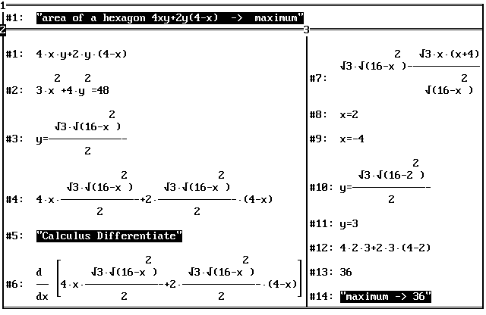

At the end of the test I collected the books and discs, the latter of which I printed out at home. The time it took me to print out the examples was easily made up by the advantage of the prints' good readability as well as the fact that - in case of a correct start and planning - the students’ work was without mistakes.

The second model time-sharing on the same computer between two students is only sensible if 50% of the test and time can be worked on without a PC and 50% with a PC. This model was partly used in the Austrian CAS I project (DERIVE). The two students sharing the time of working on the computer, got different examples. Changing turned out to be no problem.
The German report of the Austrian CAS I project says,
„After having finished his work on the PC, the student had to save the file and to quit DERIVE, thereby making the PC available for the second student.“ (HEUGL, 1996)

The third model, 50% team work alternating with 50% single work on the same computer, is part of the concept MATHS & FUN with MATHEMATICA. The concept can be studied under the homepage http://www.mathsnfun.ac.at/mf/EnglischeVersion/index1.htm. It is an educational experiment at the Business Academy I in Graz.
Two out of three mathematics lessons per week are in the computer lab, where the students have to work in teams of two and this is the reason why they write their tests in teamwork, too. Most students involved have reacted very positively on those team tests within the framework of educational experiment. However, there has also been some very negative feedback, but also some suggestions of improvement on the part of the students.
„I think teamwork is super, all the same each test should include a part which must be done individually, perhaps the relationship should be two thirds team work and one third individual work. When working on your own you can show your own performance much better than in a team. I would draw lots to decide on who is to work in a team. This would be the fairest procedure.“ (WILDING, 1999)
In 1998 this project was also carried out in two sections for the final examination in maths (A-Levels) for the first time. In the first two hours the students had to solve a problem concerning statistics and probability calculus in teamwork and the next two hours they had to use for their individual work on two different tasks given. If students of a team finished their teamwork before the end of the two hours, they could use all the remaining time for their individual work. Assessment: teamwork 44% and individual work 56%; at least 55% was necessary to achieve a pass.

But the real goal is one student per computer.

In the German report of the Austrian CAS I Project (Derive-Project) H. HEUGL writes: „It would be ideal if every student had a portable CAS-calculator, which could be
linked up with the CAS in a computer lab, in his school bag.“
In the Austrian CAS II Project (TI92-Project) 1997/98 the students of the seventy research teachers wrote their tests in mathematics with the TI-92. At their final meeting in August 1998 the teachers collected their most important and sometimes unexpected results:
(LECHNER/WURNIG, 1998)

- the problems in tests have to be more goal oriented → text longer instead of shorter.

1) The curve, which a flying object makes in the air is defined through the graph of the following function: f(t) = 45 + 20t - 5t² . h means the height and t the time. Draw the curve of the flying object in the (t, h) - co-ordinates system by using the TI-92 in your test book!
- At what time does the object reach the highest point of the trajectory and when does it hit the ground (h=0)?
- At what height does the trajectory start and when does the object reach the same height again?
Explain your answers!

- for solving problems it is very important not always to insist on the use of the TI-92.

- students find new ways with the TI-92 → more work for the teacher

- TI-92 has no floppy → much documentation in test book, therefore fewer examples.

The point P = [-8;-3] is to be reflected on the line g: 3x+2y+4=0 (Sketch a diagram on the work sheet!) What are the co-ordinates of the reflected point?
(a) First solve the problem geometrically in your test book!
- Solve the problem in an algebraic way with the methods of the analytic geometry on the work sheet! Write down your plan in the left column and document the important interim results in the right column! Do the calculations without the TI-92 on the flip side!

left: steps of the plan! | right: TI-92 documentation!
P  g1: 3x + 2y + 4 = 0  g2 = g( ∋ P, ⊥ g1 )  g1 ∩ g2 = {S}  S=(P + P*)/2 → P* = 2S - P | [-8;-3] → p  [3;2] → n  X = P + t . n  [x = 3t - 8, y = 2t - 3]  3.(3t - 8) + 2.(2t - 3)+4=0  SOLVE(ans(1), t) t = 2  S = [-2;1]  P* = [4; 5]

difficult decision: What is to be the minimum knowledge in mathematics without the TI-92?

1) Solve the two formulas per hand according to the indicated variables!
a) v = ? (no double fraction in the result!)
2
g·t
y = v·t - ——————
2
b) h = ? (no double fraction in the result!)
2
m·v
e = m·g·h + ——————
2

difficult decision: What minimum knowledge of TI92-commands is an absolute must?

- Substitute the number 7 for x in the term 12x-20:

IL:______ 12x-20⏐x=7___________________OL:______________64_________________

- Multiply the following terms: (3x²+7) (2x-3)

IL:___ EXPAND((3x²+7).(2x-3)____________OL:____ 6x³-9x²+14x-21________________

- Convert the result of (2)into the input of (2):

IL:____ FACTOR(6x³-9x²+14x-21)__________OL:_____ (3x²+7).(2x-3)_______________

- Solve the equation 3x-7 = 4(4x+2) using the TI-command SOLVE:

IL:_____ SOLVE(3x-7=4.(x+2),x)__________OL:_______x=-15/13___________________

- modules and programmes are a good chance for good students
→ a new problem for bad students.

Calculate the perpendicular distance of the point P from the line AB with the formula taught:

[0;-1] → a : [-3;4] → n : [-5;4] → p
IL:___dotp(p-a,unitv(n))_________________OL:______7___________________________

A new model of assessment

In spring 1999 a team of teachers under the leadership of H. Heugl (ACDCA) developed some variants of a new model of assessment. In accordance with the Ministry of Education experimental studies to test the new model were carried out in 1999/2000.
I chose to use the following variant in form 11:
The fundamental idea of this variant is to use the pre-set time for written tests in a school year - 350 minutes in form 11 - in different ways:
- For short tests - up to a maximum of 25 minutes - to check reproductive skills or reproductive knowledge with or without CAS.
- For one longer test per half-term, e. g. 100 minutes, to check problem solving skills. There should be sufficient time to experiment, and to use materials which have been worked out at school or at home.
- For working out a short chapter of mathematics, which has not been dealt with at school. Each student should prepare his short chapter in written form at home and present it to his classmates at school.
The fundamental idea is
- to remove the separation between written and oral exams.
- to remove the separation of product-oriented tests and process-oriented oral exams.
The students of form 11 (21 male students) participated in form 9 (1997/98) in the Austrian TI-92-Project and are working fairly well on their own with the TI-92. A further important reason was that the class was in England or France respectively from September 25^{th.} till October 18^{th.}.
The new model of assessment gave me a good chance to write a short test (25 minutes) after their first week of instruction before they went off. Besides I saw a good chance to get them down to work more quickly after their return to school by writing a second short test (25 minutes) within four weeks.
For the short span of time before their departure equations of higher degree (n ≥ 2) and complex numbers were well suited for instruction. Only few students were absent and the results of the test were satisfactory.
After the students came back they had to learn about the analytic geometry of the circle. In the 2nd Test the students had to use the new formulas to solve standard problems and besides they had to use the TI-92 in an efficient way. The students had to solve four easy problems with the TI-92. In problem 1 the TI-92 could only be used to check the result. I/O means input/output of the TI-92.

- Circle: x² + y² - 8x + 10y = 0 Calculate M = (m, n) and r

I: x²-8x+16+y²+10y+25=16+25
I: factor(x²-8x+16,x) O: (x-4)²
I: factor(y²+10y+25,y) O: (y+5)²

2) What is the distance from line g: 3x - 4y = 12 to k: M=[-5, -3], r = 2

I: dotp([-5,-3]-[4,0],unitv([-3,4]) O: 3

- Calculate one of the two intersection points of the line g with the circle k!

g: X = [7, -4] + t . [3, -2] k: (x-2)² + (y+5)² = 65 X = [x, y]

I: (x-2)² + (y+5)² = 65 | x=7+3t and y=-4-2t O: 13t²+26t+26=65
I: solve( 13t² + 26t + 26 = 65, t) O: t = 1 or t = -3
I: [x, y] = [7, -4] + t . [3, -2] | t = 1 O: [x = 10 y = -6]

- Find the equation of the circle tangent in point B of the circle k:

k: ([x, y] - [7, -2])² = 20 B = [3, -4]

I: dotp([x,y]-[7,-2], [3,-4]-[7,-2])=20 O: -4x -2y + 24 = 20

The four problems were prepared in the mathematics lessons. The aim of the 25-minute-test was to check the minimum knowledge in analytic circle geometry in a reproductive way. After dealing with the conic sections in the mathematics lessons the next test was a problem-oriented test of 100 minutes. The three problems were intentionally taken from the three chapters: analytic geometry in R³, conic section geometry and calculus.
The following problem 3 (BÜRGER u.a., 1991) could either be solved with the new concept of calculus or with the possibilities of the TI-92.
Supposing a point object is moving on the curve of the function
f: x → (1/4) . (x³ + 2x² - 3x), [-2;2] → R
and is striking a wall (x=2). Find out the size of the angle of impact?
Sketch a diagram oriented by the graphic window of the TI-92!

- 3 students calculated the slope k of the tangent for x=2 in the home window (first derivative) and afterwards the angle of impact with tan⁻¹(k).
- 3 students tried to make a drawing with the help of the co-ordinates given in the TRACE-Mode of the graphic window and then tried to measure the angle.
- 9 students produced the tangent inclusive the equation in the graphic window with the command tangent.

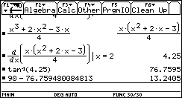
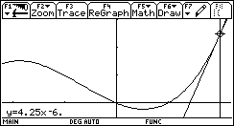

- 2 students of the 9 plotted the tangent with the help of this equation and then measured the angle.
- 3 students of the 9 saw k in the equation of the tangent and used the command tan⁻¹(k).
- the last 4 of the 9 took k (= 4.25) of the equation of the tangent and with the direction vectors [1, k] and [0, 1] they calculated cos(α) with the command dotp.

In the 2nd semester I asked them to solve two problems in stochastics and two problems in calculus in my 1st test. At first glance one of the problems seemed to lead to different results when using PC-DERIVE or TI-DERIVE.

3 2
Create the function F(x) := ‹(2·x - 3·x ) for x>1.5 and x∈R

F(x + h) - F(x)
and define with this function —————————————————
h

Compute the limit for x → 0 and compare the result with the 1st derivative of F(x).

The solution of this Problem with PC - DERIVE:

3 2
F(x) := ‹(2·x - 3·x )

F(x + h) - F(x)
—————————————————
h

‹(2·x + 2·h - 3)·¦x + h¦ ‹(2·x - 3)·¦x¦
—————————————————————————— - ————————————————
h h

€ ‹(2·x + 2·h - 3)·¦x + h¦ ‹(2·x - 3)·¦x¦ ‚
lim ¦—————————————————————————— - ————————————————¦
h˜0 h h ƒ

3·(x - 1)·SIGN(x)
———————————————————
‹(2·x - 3)

x : Real (1.5, –)

3·(x - 1)
————————————
‹(2·x - 3)

d 3 2 3·(x - 1)
—— ‹(2·x - 3·x ) = ————————————
dx ‹(2·x - 3)

The same way of solution done step by step with TI-DERIVE leads at first glance to another result. But with the same common denominator you can transform the TI expression into the PC-expression.
Another experience I made, is due to the students. Some students were frightened by the expression containing sign(x) and |x| on the home screen and stopped working. Some students entered the quotient in the whole length and declared the domain of x (x > 1.5) at the beginning. When they entered limit (ans(1), h, 0) they got the message „undefined“. If you enter the function and the domain of x (x > 1.5) at the beginning, you have no troubles to get the right result.

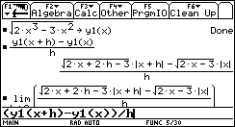

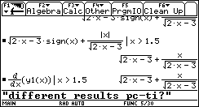
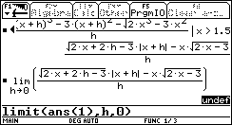

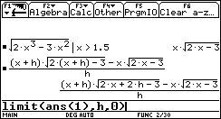

One month later the students had to write the problem-oriented test of 100 minutes. As in the 1st short test in the 2nd semester, the students had to solve two problems in stochastics and two problems in calculus. The problems in calculus were Geometric Maximum and Minimum Problems of the type R. J Hill (1994) has shown with PC-DERIVE.
You have to find a function to be extremized in two variables and a constraining relation. The constraining relation is to be solved for one of the variables. After the substitution for one variable you can plot the function in the graphic window. The TI-92 helps you to find immediately the wanted points of the plotted function by using the command Minimum or Maximum.
The 2nd way is the traditional way with the 1st derivative of the function with one variable. With this traditional way 16 of the 18 students got the right result. 11 of the 16 students got the right result on the graphic window, too.
The problem:

A segment of a hyperbola is enclosed by the line x = 7 and the hyperbola, which is given with the equation 25x² - 4y² = 100. Inscribe into this segment a rectangle of maximum area.

9 of the 11 students having the two right ways of solution had taken as variable the x co-ordinate of the point of the hyperbola.

2 of the 11 students having the two right ways of solution had taken as variable the length of the rectangle.

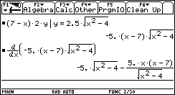

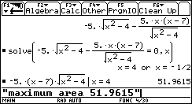

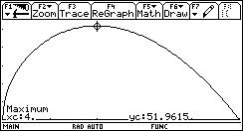

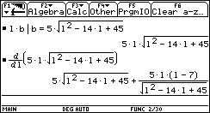

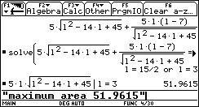

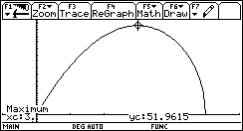

The shorter tests and longer problem-oriented tests had a very different impact on my students of the 11th form. Many students did not work hard enough for the short test in which the basic skills were examined by means of easy short problems and so the test results were bad. The problem-oriented tests, which were written later on, were taken more seriously, because they wanted to get good marks in their reports and consequently the achievements were much better.

The preparation of a short chapter of mathematics at home and the ensuing presentation at school proved to be the most difficult part on behalf of the students. Most of the students had never before prepared a disposition for a theme at school. It took me two lessons and many discussions to make even good mathematicians understand how to prepare an acceptable written and oral presentation.
At the end of the school year an evaluation will be carried out by the Centre of School Development in Graz. The results will be presented to the research teachers at a meeting in autumn 2000.

REFERENCES

ASPETSBERGER, K:/ FUCHS, K. (Eds.): The AUSTRIAN DERIVE Research Project
The International DERIVE Journal, 1996, Vol. 3, No. 1.
BÜRGER, H./FISCHER, R./MALLE, G.: Mathematik Oberstufe 3, Verlag Hölder-Pichler-
Tempsky, Wien, 1991
ETCHELLS, T./BROWNE, R./ELLIS, W./TOWNEND, St./WURNIG, O.: Assessment.
In: BERRY, J./MONAGHAN, J. (Eds.): The State of Computeralgebra in Mathematics
Education, Chartwell-Bratt, 1997.
HEUGL, H./KLINGER, W./LECHNER, J.: Mathematikunterricht mit Computeralgebra-
Systemen. Addison-Wesley, Bonn 1996.
HILL, Robert: Using DERIVE in Teaching Calculus Geometric Maximum and Minimum
Problems. In: HEUGL, H. / KUTZLER, B. (Eds.): DERIVE in Education -
opportunities and strategies, Chartwell-Bratt, 1994.
KLINGER, W.(Hg.): Der Mathematikunterricht im Zeitalter der Informationstechnologie,
CD-ROM, ACDCA, 1998.
LECHNER, J./WURNIG, O.: Schularbeiten, 5. Klasse. In: KLINGER, W.(Hg.): Der Mathe-
matikunterricht im Zeitalter der Informationstechnologie, CD-ROM, ACDCA, 1998.
WILDING, H.: Interaktive Lernumgebungen im Unterricht. Das Lernsystem Math School
Help 98. In: Kandunz, G. u.a. (Hg.): Mathematische Bildung und neue Technologien, Teubner, Stuttgart, 1999.
WURNIG, O.: Mathematikschularbeiten mit DERIVE - Erste Erfahrungen. In: Böhm, J. (Ed.):
Teaching Mathematics with DERIVE, Chartwell Bratt, Bromley, Kent, 1992.
WURNIG, O.: From the first use of the computer up to the integration of DERIVE in the
teaching of mathematics. The International DERIVE Journal, 1996, Vol. 3, No. 1.

