A. Cvetkovič, D.Ivanec, K. Starin, T.R.Špegel, Gimnazija Jožeta Plečnika, Ljubljana: QUADRATIC FUNCTION - EXAM QUESTIONS WITH USE OF COMPUTER ALGEBRA SYSTEMS

ABSTRACT

The quadratic function was chosen for our study in which we wanted to analyze some of the existing exam questions according to the skills and abilities they test and according to the use of CAS. We prepared two separate test papers that would complete each other with the aim to test skills and abilities students should master within this topic. We wanted to check whether the operational goals could be achieved to a higher or to e lesser degree by using CAS. Finally we reconsidered the advantages and disadvantages of using CAS in exam questions.

1.TEACHING WITH CAS IS FUN … BUT IS IT POSSIBLE TO USE IT FOR TESTS?

In the last few years we were acquainted with graphing calculators that enabled the use of computer algebra systems(CAS) and dynamical geometry software (CABRI) in classroom. As a member of T^3 – Europe group and Comenius project our school has had the opportunity to obtain a certain number of graphing calculators TI-92.

We have been using them experimentally to make lessons more effective or more interesting and most students have accepted the novelty with interest and enthusiasm. But so far we have not considered the use of CAS in exam questions .

The article Exam questions when using CAS for school mathematics teaching, by dr.Kokol, University of Maribor, was an incentive for serious consideration of this possibility and the result is the following contribution to this conference .

In her article the author states that using CAS will change the teaching methods, the contents of what we teach and consequently the exams.

In traditional mathematical lessons a lot of time is dedicated to learning and executing the algorithms instead of learning underlying mathematical concepts . There is not much focus on the use of mathematics, which is aimed at solving problems . Students are bad in applying mathematical knowledge in other sciences like physics or chemistry because there is a lack of correlation between mathematical lessons and other. Many teachers feel frustrated to teach »recipes« instead of developing students' sense of logic and creativity .

Students' approach towards learning mathematics could be simply described in two ways.

The majority are quite keen on practicing algorithms without asking questions about the use of it. They feel safe because they know from their experience that strenuous work will be awarded with a medium or even with a good mark without a necessary understanding of mathematical concepts.

Lesser number of students (often more intelligent but idle) want to know in what cases particular algorithm is used, which could be in certain cases a sign of protest abut sometimes a sign of real interest., If a teacher refuses to give the answer these students often use motivation to work.

Teacher is faced with a sad paradox that talented and creative students might be unsuccessful in mathematics because they do not practice enough to master techniques, but on the other hand, those who are excellent in performing algorithms could not use them because they do not see the point .

With the use of CAS the focus of a mathematical lesson(topic) could and should be shifted from performing mathematical operations to using them and above all to understanding of mathematical concepts. The change of teaching methods will inevitably effect the ways of testing mathematical skills and abilities and thus exam questions.

We chose Quadratic function and its applications as the field of our study in which we wanted to analyze some of the existing (traditional) exam questions according to the skills and abilities they test and according to the use of CAS.

We prepared two separate test papers that would complete each other with the aim to test skills and abilities students should master within this topic.

We wanted to check whether the operational goals could be achieved to a higher or to a lesser degree by using CAS.

Finally we reconsidered the advantages and disadvantages of using CAS in exam questions,
whether there is a realistic possibility to use CAS widely in regular lessons with regular population ,
what problems might occur
and what changes should be made in the curriculum and in educational system to make new methods successful.

2. ANALYSIS OF CLASSICAL EXAM QUESTIONS

Dr. Kokol divides classical exam questions into various categories according to their usefulness in CAS environment ( with respect to their significance of testing abilities and skills) such as :

a) CAS insensitive questions

- CAS devaluated questions

- Questions changing with technology, where CAS is just the tool to do quickly and reliably the routine(technical) part but does not impoverish mathematical concept We call these CAS - applicable questions

Here we give some examples of the following groups.

GROUP 1. CAS – insensitive questions

- Write the function that is given by the graph below. Reflect the graph:
- With respect to x-axis
- With respect to y-axis
- With respect to the origin and each time write the reflected function.
d) Move the graph to get even function and write its equation. Is there only one solution?
Explain the answer

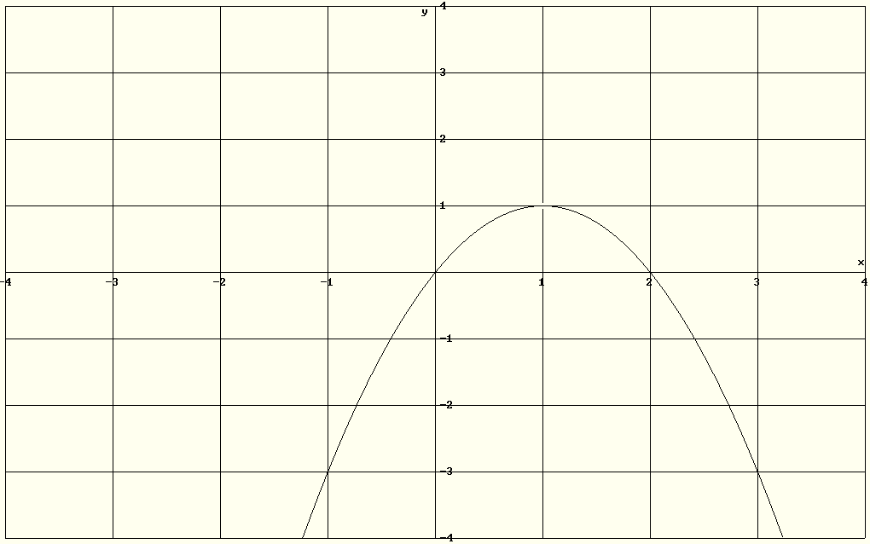

- Find a quadratic equation if sum and product of its roots are equal to –2.

- Find the function f(x) = ax² + bx + 5 that satisfies conditions: f
is even and A(2,7) lies on its graph.

All questions testing theory e.g. definitions , derivation of certain rules could also be cathegorized into this group.

GROUP 2. CAS-devaluated questions

All questions testing ONLY techniques of solving equations, graphing or formulas could be found in this group. Here are some typical examples.

All that remains of mathematics is that not getting real roots with the command SOLVE means to use CSOLVE to get imaginary ones (e.g. 1c). DERIVE also discards extraneous roots of radical equations (e.g. 1e).

- Solve the equations:

- 4x²-1 = 0

- 5x² +7x + 24 = 0

- x⁴ -5x² +4 = 0

- ((x² +1)/x)² -9((x² +1)/x) + 10 = 0

- 2x + (2x² + x – 1)^{1/2} = 1

2. Graph the functions f(x) = -x² +6x –5 and |f(x)|.

3. Solve graphically : 2^{x} = 2x² -4x +2

4. For given parabola y= x² + 10x + 21 find intersections with coordinate axes and vertex.

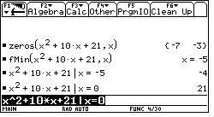

GROUP 3. CAS applicable questions

In the following examples calculator is used as a tool to reduce time needed for certain routine methods or calculations. The amount of time saved depends on the example and on the skill of the user. But none of these examples can be solved without understanding of mathematical concept that remains essential.

- Use two methods to find intersections of parabolas y = x² – x – 12 and
y = -3x² + 15x - 12 .

Mathematical contents: - knowing appropriate methods
- calculating y after solving equation to present results as points

TI-92 will do graphing and solve equations

2. Find the values of m if the roots of the equation mx² -2(2-3m)x +6m + 1 = 0 are:
a) real and equal
b)real and unequal
c) imaginary

Mathematical contents: - knowing the formula and meaning of discriminant for the roots of quadratic equation
- reading solutions of quadratic inequality from the graph of corresponding D( m)

TI –92 will simplify the discriminant, solve equation and graph D(m)

3. The sides of triangle measure 3, 5 and 7 cm. Each of them is increased by the same length in order to obtain the right triangle. Find the sides of this triangle.

Mathematical contents: - writing data in mathematical form
- using Pithagorean theorem to form the equation
- discarding negative solution

TI-92 will just solve the equation.

4. The organizers of a rave concert intend to use large, flat expanse of land with a long, straight wall as one boundary. The rectangular enclosure is to be made from a total of 1000 metres of fencing on three sides with the wall for the fourth side. Find the dimensions of the enclosure to obtain maximal area of it.

Mathematical contents: - drawing a sketch with appropriate symbols
- expressing one side of rectangle wit another and given data
- using formula for area and express area as quadratic function

Calculator will just calculate maximum.

5. Solve the inequality 3 < x² + 2x < 8.
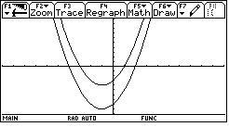

Mathematical concept:
- changing inequality into system of two inequalities
- transforming the problem of solving inequality to finding values of x where the corresponding graph is above (under) x-axis
- finding the final set of solutions.

6. Find the area limited by the graph of f(x) = x² - 5x + 4 and x-axis between zeros.

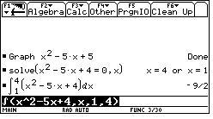

Mathematical contents: - knowing the geometrical meaning of defined integral
- knowing the link between indefinite and definite integral
- interpreting the result - area is nonnegative

.7. Given the function f(x) = x|x-2|, draw the graph, find the tangent to the graph in the point T(0,f(0)) and find the area between the tangent and the graph.
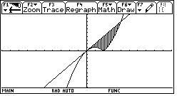
Mathematical concept: - planning steps of solving
-making conclusions from the graph
- using integration to find area
Calculator will be used for graphs, tangent, integration .

3.TEST PAPERS

We wanted to prepare two test papers that would in combination cover the skills, abilities and theory knowledge of our topic.

By our mathematics curriculum student is expected to :

- write the quadratic function in standard form, vertex form and zero form knowing the meaning of parameters
- derive the coordinates of vertex by completing the square
- graph the function as the translation and dilatation of parabola y = x²
- solve simple quadratic equations by factoring, using quadratic formula
- solve equations of the type ax^{2n} + bx^{n} + c = 0
- solve simple radical equations
- find zeros of quadratic function and know the correlation between discriminant and zeros of the function (roots of the equation)
- know and use VIETE rule
- discuss mutual position of parabola and line (two parabolas)
- apply quadratic function to solve extremal problems
- transform word problem into quadratic equation and solve it
- solve quadratic inequalities and systems of two inequalities

Solving quadratic equations where substitution is needed or “difficult” radical equations will be allowed by calculator.

The first paper has to be done without the use of calculator.

All the questions in this paper test basic skills and techniques, knowledge of basic formulas, understanding of link between graph and equation and understanding of some general concepts. The working is technically undemanding and little time-consuming.

In the second paper CAS is used to reduce the time needed to perform some operations or algorithms, time-consuming calculations and graphing. The emphasis is on understanding the problem, analyzing it, splitting it in steps towards solution and commenting on the results.

We compared the time needed for work with TI-92 and without it (presuming that the user is acquainted with calculator).

PAPER 1.

- Solve:

- x²– 3 = 0
- 2x² – 0.5x - 3 = 0
- 2x² – 3x = 0
- x⁴ – 6x² + 5 = 0
- (5+2x)^{1/2} = x +1

- Find the value of k supposing the roots of the equation (x+k)² = 2-3k are equal.

3.Derive the coordinates of vertex of parabola y = 2x² – 12x + 10. Find the intersections with coordinate axes and graph parabola.

4. Discuss mutual position of the line y = 2x + n and parabola y = x² according to parameter n.

5. Given the equation (a + 1)x² + (9a – 1)x – 9a = 0, find the value of a supposing the roots are reciprocals

- a) Write the quadratic function represented by the graph.
b) Move the graph to get an even function and write its equation. Is there only one
solution ? Give the reasoning for your answer.

7. Find the quadratic function with y-intercept 16, axis of symmetry x=3, vertex lying on the line y + 2x + 4 = 0.

PAPER 2.

- A square piece of cardboard is to be made into an open box with dimensions
a cm x a cm x 3 cm. The area of the box should be at least 133 cm². What is
minimal side of the square? Sketch!

- Describe two possible ways to find the values of x for which the fraction $\frac{x^{2}−2x}{x^{2}−4x+3}$ is positive.

- Find the quadratic function with points A,B,C lying on its graph $A\left(2,−\frac{1}{4}\right),B\left(−4,\frac{\text{71}}{4}\right)\text{ in C}\left(\text{-2,}\frac{\text{23}}{4}\right)$.

- Find intersection points of parabola y = 4x² + 3x + 5 and line

y = −21x + 95. Describe two possible ways to find the answer.

- Area of an isosceles triangle with side length 20 cm is 192 cm². Find the base.

- Find the range of values of m that make f(x)=mx² + (m+2)x + m negative for every real x.

- A ball projected vertically upward is distant s meters from the point of the projection after t seconds, where s = 64t – 16t².
- At what times will the ball be 40 m above the ground?
- Will the ball ever be 80 m above the ground?
- What is the maximal height reached?

- Find the area of the largest triangle which can be inscribed in a right triangle whose legs are 6 and 8 cm respectively, two sides of rectangle lying on triangle’s legs . Sketch!

Comments on Paper 2

Questions 1, 2 and 6 deal with inequalities which is inproportional to the time dedicated to the contents within this topic. But each of these questions is of different type and as such interesting. The final choice should be made by the teacher.

Ad.1. Student has to transform word problem into quadratic inequality and solve it graphically. He should discard negative solution and write the answer. Calculator is used just for graphing , not much time will be saved.

Ad. 2. As it is impossible to check which method and how many methods student used to get the solution we think it reasonable to find the answer by any method with short description of both methods . E.g. 1) solve rational inequality graphically;
2) solve two systems of quadratic inequalities (also graphically)., The first method saves 4/5 of time, second is more time-consuming.

Ad.3. Student has to write system of three linear equations. Matrix method gives instant results, ¾ of time saved.

Ad.4. As in example 2., we test theoretical knowledge of different methods. The choice is left to the student, although graphical method is not convenient with these data. Avoiding calculation mistakes is more important here than saving of time..

Ad.5. The major part is done by student. TI 92 is used just to solve biquadratic equation . About 2/3 of time is saved.

Ad 6. TI 92 is used just to calculate the discriminant D(m) and to graph it in order to find solutions of inequality. Minor saving of time.

Ad.7. Structured question, where calculator gives graphic presentation of ball’s way. It can be also used to find maximum, the rest is done easily by hand.

Ad. 8. Major part is done by the student. Calculator is just used to find maximum of quadratic function to save some time and avoid calculating mistakes

It is obvious that test paper with the use of CAS does not need to be easier to solve than a classical one. On the contrary, it can be more demanding in mathematical concept and understanding of the problem. The advantage is that the time needed for graphing and tiresome calculations could be spent for reflection upon the problem, about method and about results. Teacher can give more structured questions and does not need use data leading to “nice” solutions. Student will avoid calculating mistakes and gain time which is very important for those who are slow in performing operations.

4. ACHIEVEMENT OF OPERATIONAL GOALS AND GENERAL EDUCATIONAL GOALS WITH THE USE OF CAS

Our national mathematical curriculum determines operational goals as goals of higher taxonomy degree such as:

- formation of basic mathematical notions and structures
- development of different ways of thinking and processes of thinking
- development of creative potential
- possessing formal knowledge and abilities
- learning about practical use of mathematics

More precise description is given in the matura catalogue as exam goals - skills and abilities that student should possess :

- Reading and understanding correctly mathematical texts
- precisely presenting mathematical contents(data, results) in writing, with tables, graphs or diagrams
- calculating with numbers, estimating and writing the result to certain preciseness and judging its validity
- using appropriate method
- using calculator
- using basic tools for geometric constructions
- interpreting, transforming and using correctly mathematical statements expressed by words or symbols
- recognizing and using the relationship among geometrical objects in two or three dimensions
- making logical conclusions from given data
- recognizing patterns and structures in various situations
- analyzing problem and choosing appropriate tool to solve it
- seeing and using correlation of various mathematical branches(fields)
- combining various mathematical skills and techniques by problem-solving
- presenting mathematical product in a clear and logical form with the use of appropriate symbols and terminology
- using mathematical knowledge in everyday life situations
- using mathematics as means of communication with emphasis on precise expressing oneself

It can be observed that with CAS most of these goals could be achieved to same or even to larger extent than by classical math teaching and assessment.

Also didactical advice recommends problem approach: real world problems, with emphasis on the presentation of problem in mathematical form, on the interpretation of solution.

With general use of CAS many classes which have been spent for learning and practicing algorithms, techniques and methods could be dedicated to application of mathematics in order to solve problems.

From this point of view, all seems to be in favour of mass implementation of CAS technology in mathematical or natural science education.

Nevertheless, we see some problems on the horizon.

5. WHAT SHOULD BE TAKEN INTO CONSIDERATION OR SCRUPLES OF A CONSERVATIVE TEACHER

As the first we would expose a statement also taken from the curriculum.

Calculator should be a tool after student has mastered basic mathematical skills .

We can agree on that. The same goes for basic formulas, algorithms and techniques. An old proverb says: REPETITION IS MOTHER OF ERUDITION. Teachers know how many exercises have to be done before certain knowledge is sound and how many difficult problems solved before we are sure to solve simple ones.

We are afraid that student will not learn elementary graphs if he/she does not draw hundreds of them as he has to do it now. Will he master techniques of solving simple equations by knowing calculator can do it? We fear that the general level of basic mathematical knowledge could decrease on the account of greater insight into applicability of mathematics.

And there is another, wider problem – demand of university studies. Nearly half of students’ population want to continue their studies on university. It’s rather likely that practical, application oriented approach would satisfy the needs of future lawyers, linguists or sociologists but would it also satisfy needs of future engineers, physics or mathematics?

That means that every change of technology and methods that leads to the change of curriculum or educational standards requires a thorough consideration and above all compatibility and adjustment of all educational levels.

Finally, we don’t agree with the extreme trend towards usefullness that seems to be taking over in our society with the slogan :I DISCARD WHAT I CAN NOT USE (or understand). I am afraid that the beauty of mathematics as a logical construction , a perfect system, as philosophy will be considered by majority as “not for use” and as such unnecessary . If we compare traditional mathematics taught at school nowadays to a book with recipes of exotic dishes nobody wants to taste, we certainly don’t want it to be replaced by some “User’s guide” .

At the moment we see CAS as a strong medicine that should be taken by drops to have its revitalizing effect whereas overdose could be fatal.

CAS and dynamic geometry in secondary education are a great help to teacher’s explanation, a wonderful tool to motivate students, a possibility for those not so few who understand mathematical concepts but never get the right result. It is a challenge for teachers and students and a wide field of development.

